Essbase:

When users are connected to OpBud directly, they will have access to the Essbase Ribbon.



Zoom In- Allows for zooming into a selected cell based on a zoom selection.

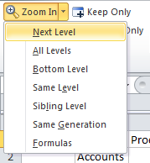

Zoom Out- Collapses the existing or current view based on the default zoom level.

Pivot- Moves a dimension between rows and columns. If there are two or more dimensions in the row or column, the user can choose to pivot the selected dimension to the POV.

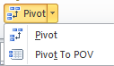

Keep Only- Selected members will be the only ones to remain on the grid for that dimension.

Remove Only- Selected members will be the the only ones removed from the grid for that selected dimension.

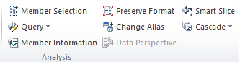

Member Selection- Allows for the selection of a specific dimension or member. Opens the member selection window.

Query- Allows for other analyses to be conducted (i.e. Query Designer).

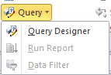

Preserve Format- Enables or disables perserving the grid formatting.

Change Alias- Allows for change the way that the members and dimension are displayed on the grid by aliases.

Smart Slice- Admin only feature, which opens up the smart slice creator.

Cascade- Allows for the seperation of reports for any or all members of one dimension.

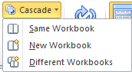

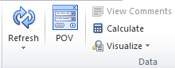

Refresh- Updates the grid with the data from the connection source.

POV- Opens the POV window, to allow for member selection for the POV.

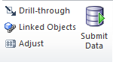

Drill Through- Access to Drill-Through reports for the selected location.

Budget Development Glossary

OBPA – Office of Budget, Planning and Analysis

Current Funds Budget “Budget Book” – a book that holds the approved budget for the year

FTE – full time equivalent based on positions and resources. 1 FTE = 1 full time position

Entity – Org / Fund / Program

Journal Voucher (JV) –– accounting or budgetary entries to record transactions, adjustments or corrections into the Banner finance system.

COGNOS - Cognos is a suite of products – Report Studio, Analysis Studio, Query Studio and Event studio. Cognos is a reporting tool.

Permanent Budget – Recurring base budget

General Fund (GF) – used to account for general operating activities related to academic and instructional programs and their administration.

Auxiliary Activities Fund – used to account for revenues and expenses of revenue-producing, substantially self-supporting activities that perform a service for, but are not themselves, educational and general activities.

Permanent Budget Entries – Adjustments or changes made to the base budget via a journal voucher.

Rule Codes – codes used to tell the Banner system how to process a transaction.

CY - Current Fiscal Year

Chart of Accounts (COA) – a systematic classification of accounts within Banner. WSU uses only one COA

Fund (F) – Identifies the source from which the money is being drawn.

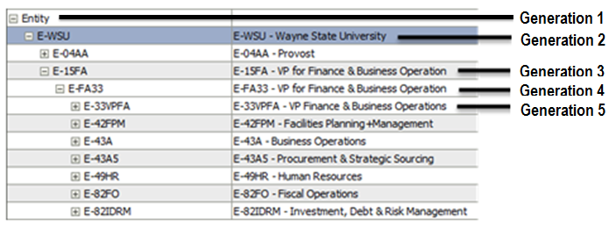

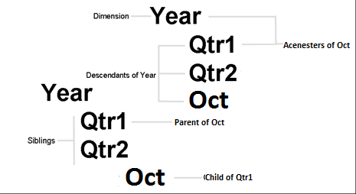

|  |  |
| --- | --- |
| Term | Description |
| Outline | The representation of the relationships among the members in the database |
| Dimension | The top most member of a dimension |
| Member | Discrete component making up a dimension |
| Parent | A member that has at least one child below it |
| Child | A member that has a parent immediately above it |
| Sibling | A child member at the same branch level as another child member with the same parent |
| Ancestor | Any member in a branch above a member |
| Descendants | Any member below a parent |

Organization (O) – identifies the budget unit of the school, college, division, or department.

Account (A) – code identifies what financial activity is being recorded. Examples: assets, liabilities, revenues, expenditures and transfers.

Program (P) – identifies the purpose of the transaction. Examples: instruction, academic support and research.

Reduction - reduction of the budget should be entered as a negative value

Adjustment - changes to previous year’s budget allocations which will include permanent transfer between SCD and entered by OBPA

Initiatives - approved new program changes that will be entered by OBPA

Reallocation - changes between account codes and across entities within their school/college/division and should net to zero

