General Fund - Hyperion Planning and Smart View
Exercise Guide

Last Update: 2017/4/7

Table of Contents
Exercise 1: Navigating to Task List 2
To Log into Hyperion Planning: 2
To Navigate to Budget – End User Task List: 3
Exercise 2: Adjusting Data in a Data Form 5
To Open a Form from the Task List and Change Page Members: 5
To Enter Data in a Form: 6
To Copy and Paste Data: 6
To Increase or Decrease Data Values: 8
To Add a Comment to a Cell: 9
To Submit Data 11
Exercise 3: Financial Reports 13
To Open a Financial Report from the Task List and select an entity: 13
To Change the Page of a Financial Report: 15
Exercise 4: Setting up a Smart View Connection 16
To Set the Smart View Connection URL: 16
Exercise 5: Smart View Ad Hoc Grid 21
To Create an Ad Hoc Grid: 21
To Change the Alias Table: 22
To Change the POV: 22
To Refresh the Grid: 31
Exercise 6: Smart View Ad Hoc Functionality 32
To Create Free Form Grid: 32
To Zoom In and Out of Members: 33
To Pivot Members: 34
To Keep and Remove Members from the Grid: 37
Exercise 6: Smart View Ad Hoc Additional Functionality 39
To Create a Query Using Query Designer: 39
To Format an Ad Hoc Grid: 43
To Create a Cascade Report: 47

Exercise 1: Navigating to Task List
GOAL: In this exercise users will log into the Hyperion Planning application and navigate to the Budget – End User Task List.
To Log into Hyperion Planning:
- Open Mozilla Firefox.
- Navigate to https://hypwebpp.ad.wayne.edu/workspace/index.jsp.
- In the User Name field, enter your Pipeline ID.
- In the Password field, enter your password.
- Click Log On.
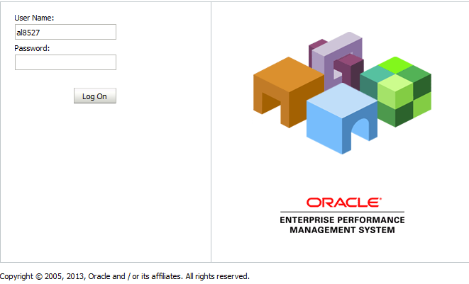

To Navigate to Budget – End User Task List:
- Click Navigate > Application > Planning > WSUPLN.
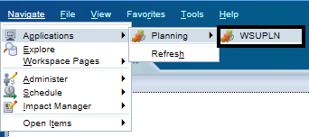
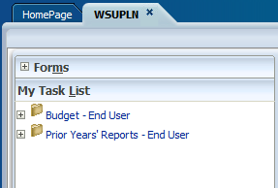
- Right click Budget – End User.

- Click Expand All Below.
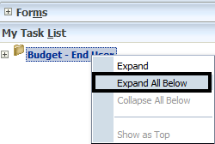

Exercise 2: Adjusting Data in a Data Form
GOAL: In this exercise users will open a form in the Budget – OPBA Task List, type data in the form cells, copy and paste data into cells, adjust values by a percentage, add a comment to a cell, and attach a document to a cell.
To Open a Form from the Task List and Change Page Members:
- Click 4.3.1 – Enter Next Year’s Budget.
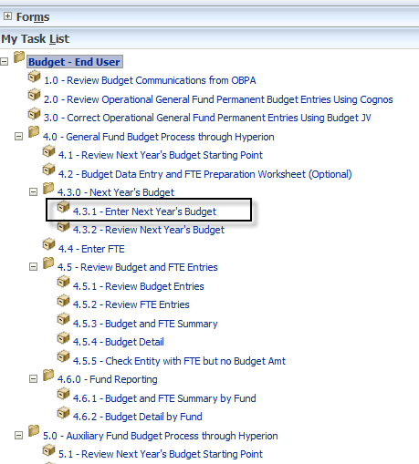
- Click the Entity page drop-down.
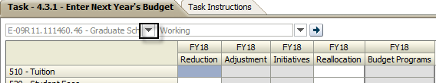
- Select an appropriate entity.

- Click Go.
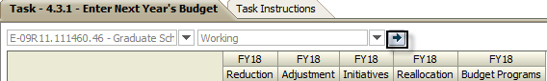
To Enter Data in a Form:
- In 612 – Non Academic Classifications Budget Pool FY18 Reduction cell, enter -20000.
- In 612 – Non Academic Classifications Budget Pool FY18 Reallocation cell, enter 1000
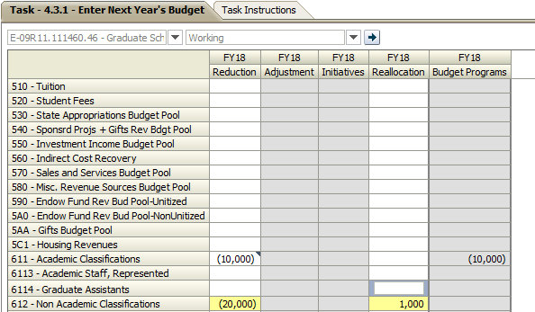
To Copy and Paste Data:
- Click and drag to select all of the cells used in the previous section (612 – Non Academic Classifications Budget Pool FY18: Reduction, Adjustment, Initiatives, and Reallocation).
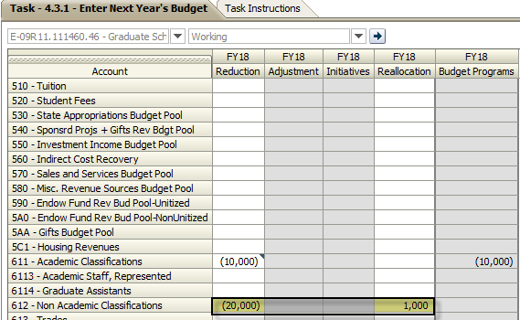
- Right-click the highlighted cells and click Edit > Copy.
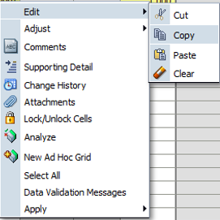
- Right Click 6113 – Academic Staff, Represented, Reduction cell, EditPaste
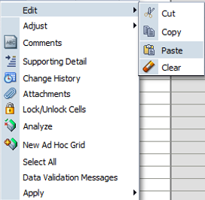
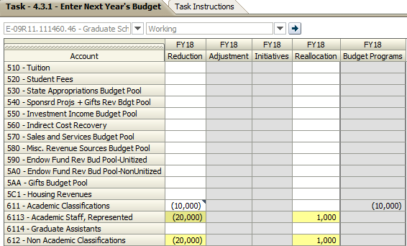

To Increase or Decrease Data Values:
- Right-click 6113 – Academic Staff, Represented, FY18 Reduction.
- Click Adjust > Adjust Data.
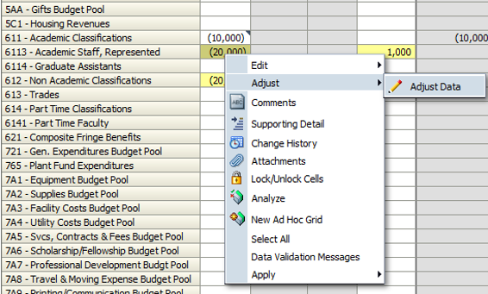
- Click By Percentage.
- Click Decrease by.
- In the text field, enter 5.
- Click Adjust Data.
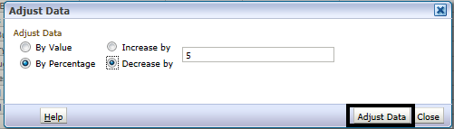
To Add a Comment to a Cell:
- Right-click 6113 – Academic Staff, Represented, FY18 Reduction.
- Click Comments.
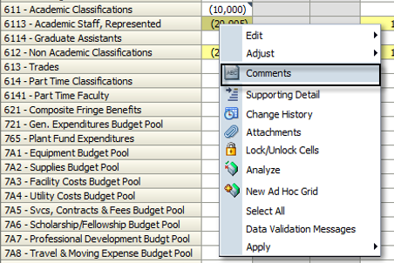
- Click “+”.
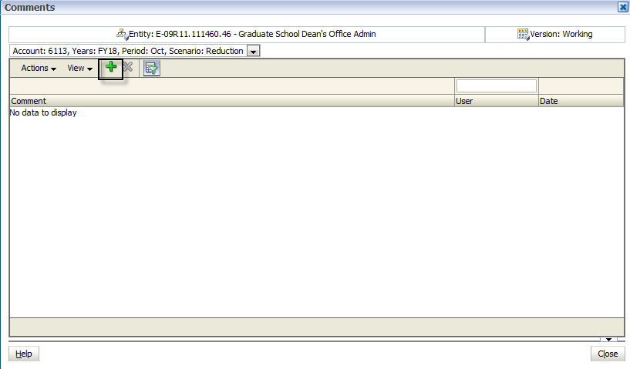
- Click in the text box and type This is a comment for training.
- Click Add.
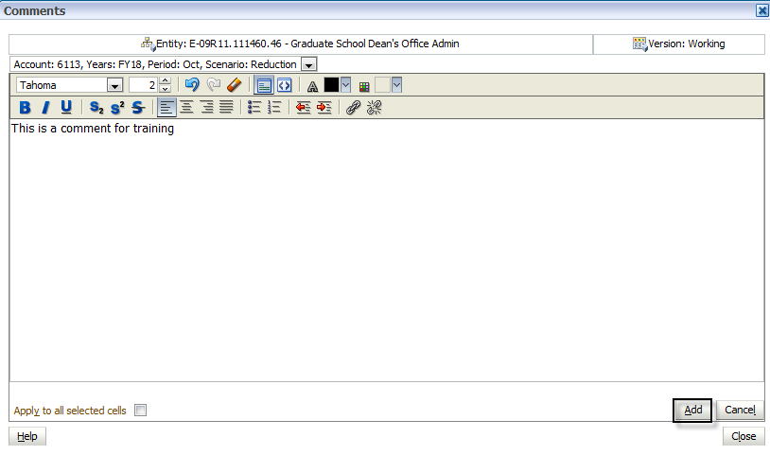
- Click Close.
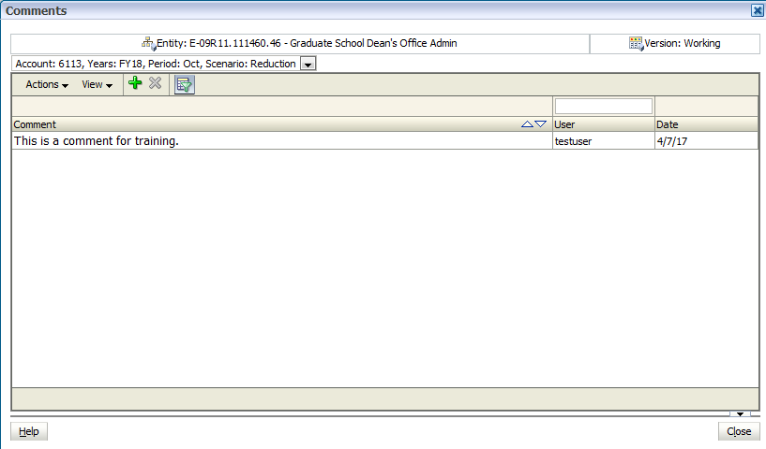
To Submit Data
- Click Submit Data.
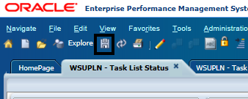
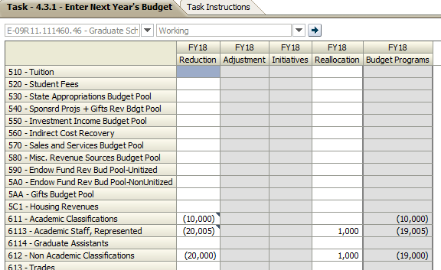

Exercise 3: Financial Reports
GOAL: In this exercise users will open a Financial Report from the task list, select a member for the report, and change the page of the financial report.
To Open a Financial Report from the Task List and select an entity:
- Expand 4.6.0 Fund Reporting.
- Click 4.6.2 Budget Detail by Fund.
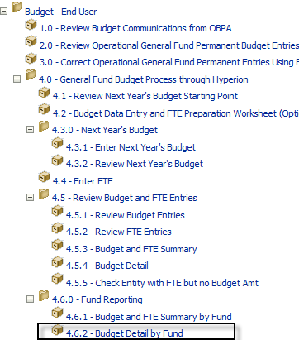

- Click Go to Member Selection.
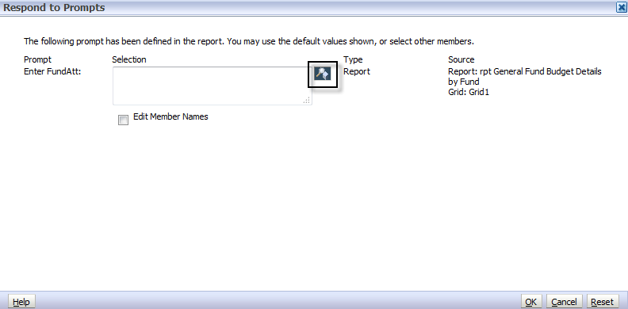
- Click a Fund
- Click Add, then Click OK
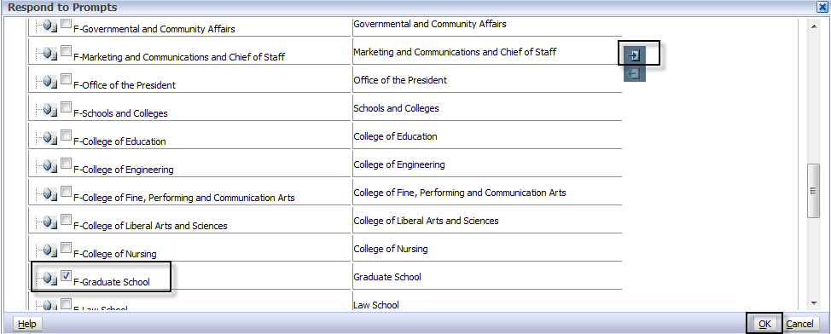
- Click OK again
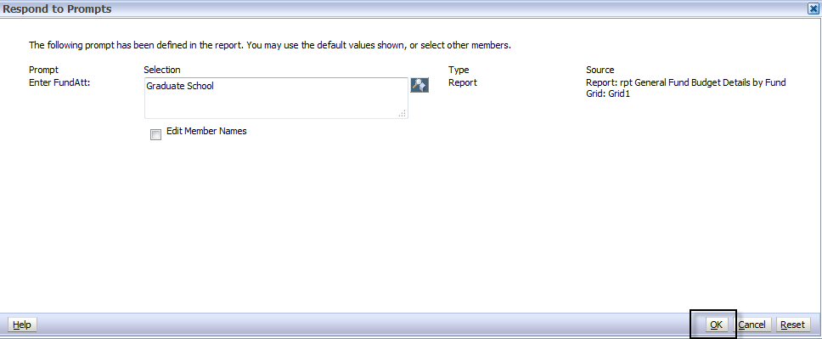

To Change the Page of a Financial Report:
- Click the Page drop-down.
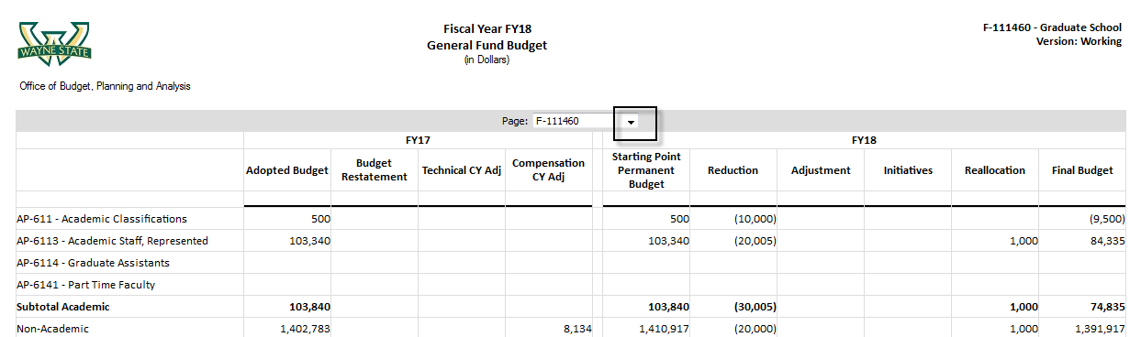
- Select an appropriate member.

Exercise 4: Setting up a Smart View Connection
In this exercise users will adjust the Smart View options to have the correct Shared URL and connect to an Essbase cube.
To Set the Smart View Connection URL:
- Open the Microsoft Excel application.
- Click the Smart View ribbon.
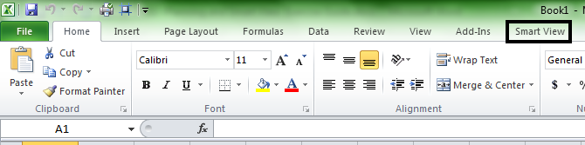
- Click Options.
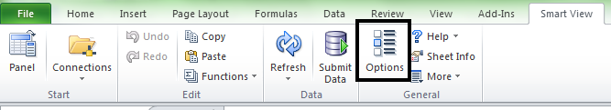
- Click Advanced.
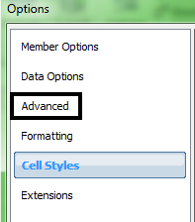

- In the Shared Connections URL: type https://hypwebpp.ad.wayne.edu/workspace/SmartViewProviders.
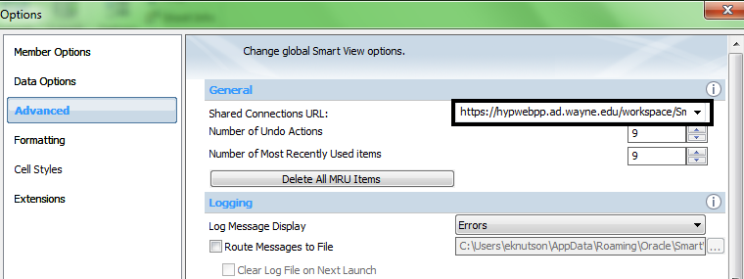
- Click OK.
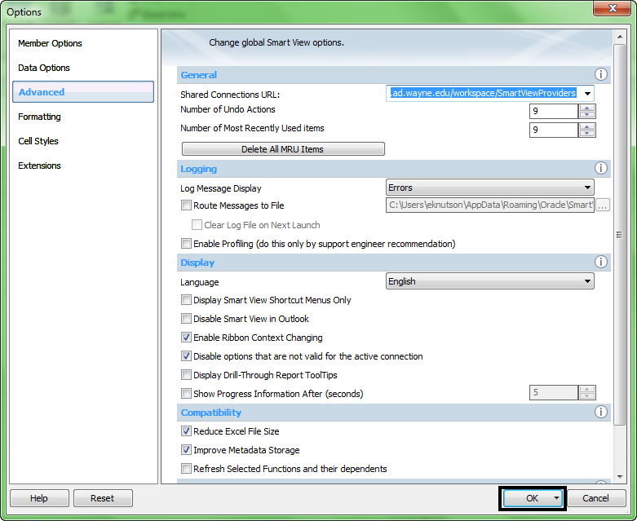

- Click Panel.
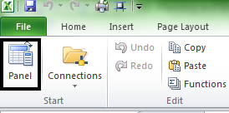
- Click Shared Connections.
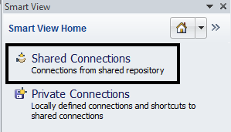
- In the Username field, enter user Access user ID.
- In the Password field, enter user password.
- Click Connect.
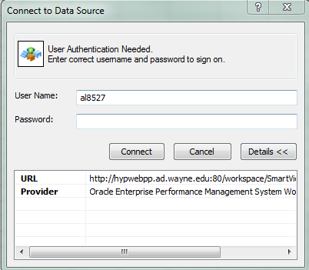
- Click the Server drop-down.
- Click Oracle® Essbase.
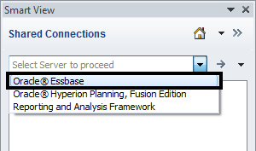
- Expand EssbaseCluster-1.
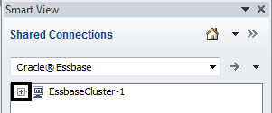
- Expand WSUPLN.
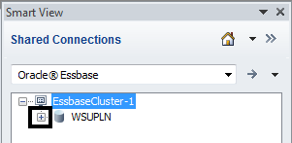
- Click OpBud
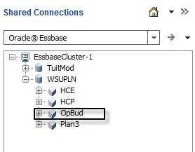
- Click Connect
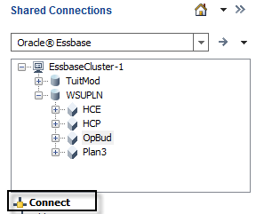

Exercise 5: Smart View Ad Hoc Grid
In this exercise users will create an ad hoc grid, change the grid to show aliases, change the grid POV, and refresh the grid.
To Create an Ad Hoc Grid:
- Click Ad hoc analysis.
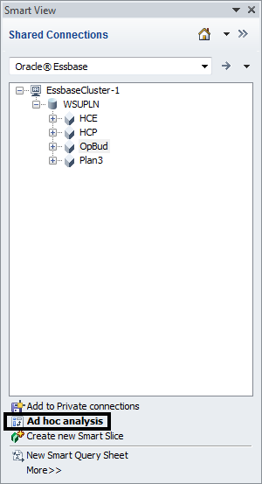

To Change the Alias Table:
- Click Change Alias.
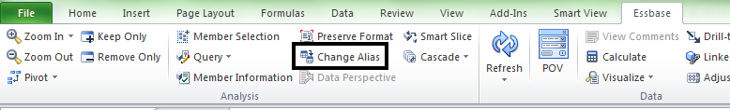
- Click Default.
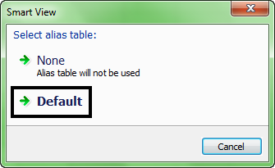

To Change the POV:
- Click POV.
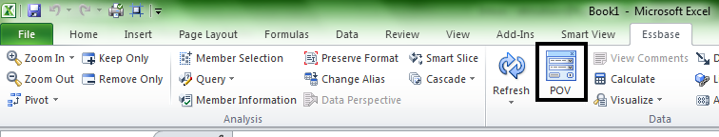
- Click the Entity drop-down.
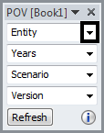
- Click … (ellipses).
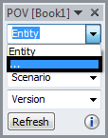
- Click in the Search box, and type in an appropriate entity name.
- Press [ENTER].
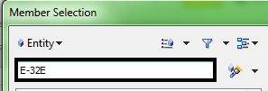
- Select the entity from the left pane.
- Click Add.
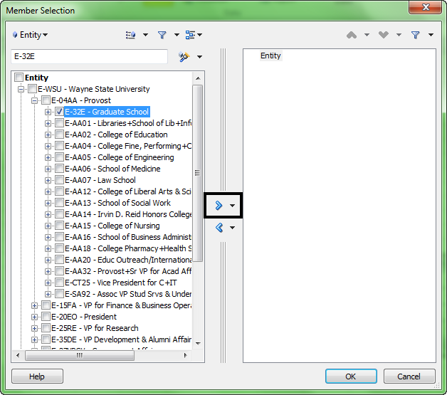
- Click Entity.
- Click Remove.
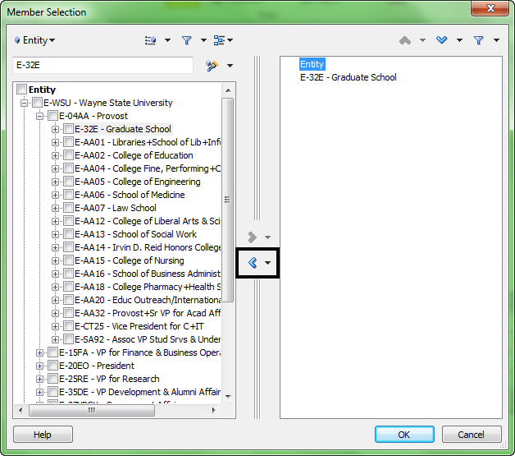
- Click the Entity drop-down and select Years.
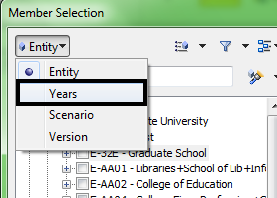
- Select FY18.
- Click Add.
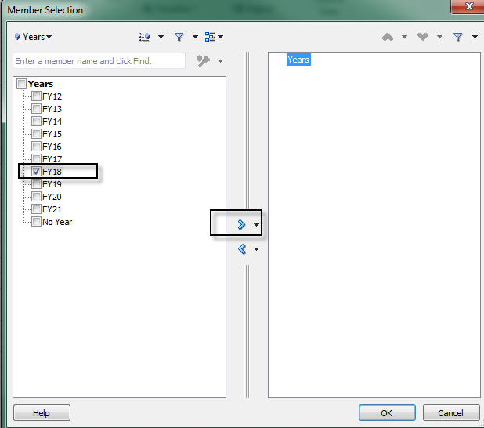
- Click Years.

- Click Remove.
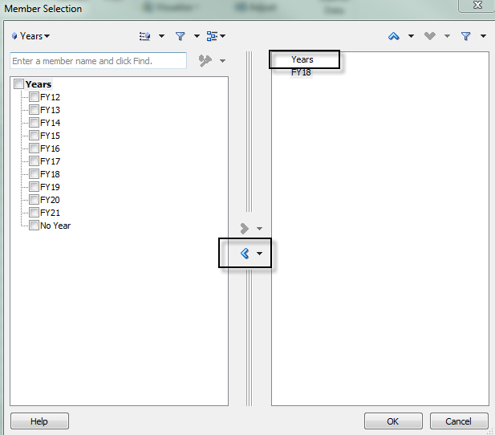
- Click the Years drop-down and select Version.
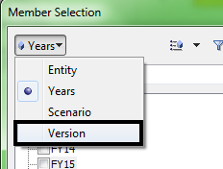
- Select Working.

- Click Add.
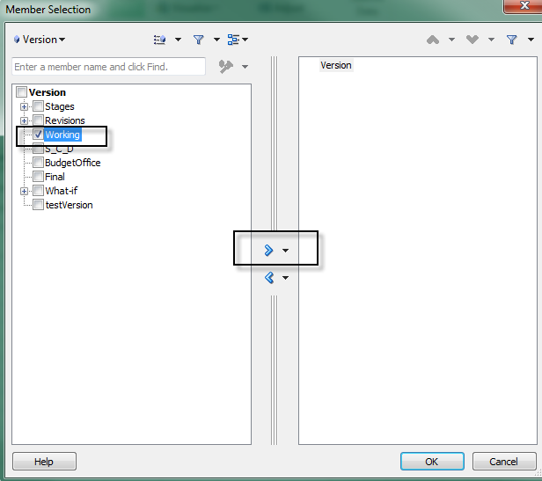
- Click Version.

- Click Remove.
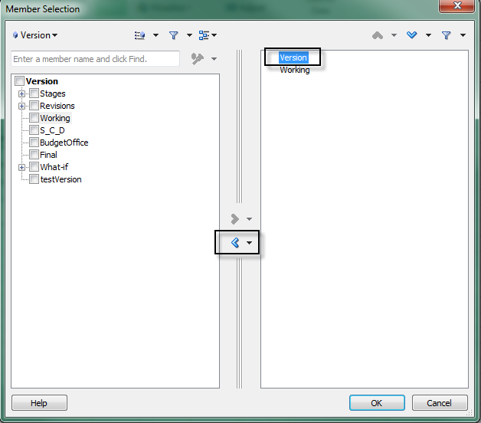
- Click the Version drop-down and select Scenario.
- Expand Final Budget.
- Select Starting Point Permanent Budget

- Click Add.
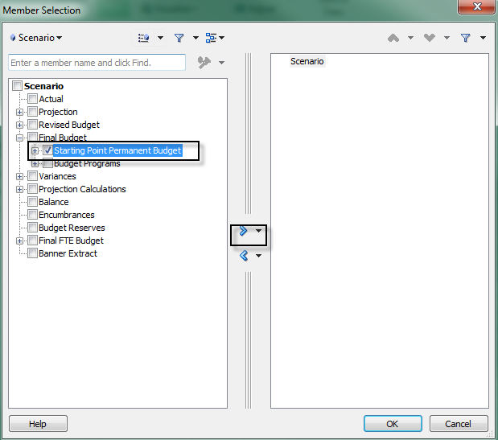
- Click Scenario.

- Click Remove.
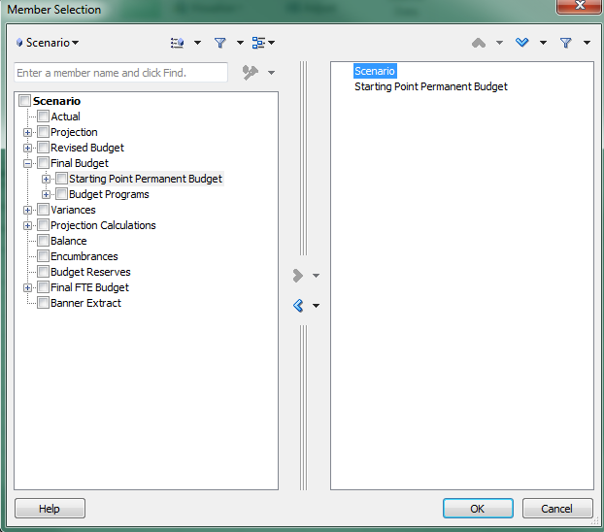
- Click OK.
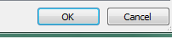

To Refresh the Grid:
- Click Refresh.
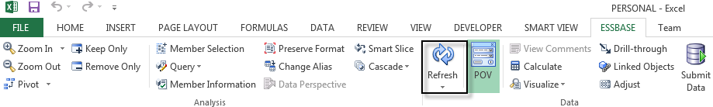
- Result:
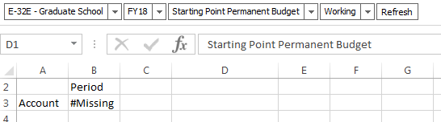

Exercise 6: Smart View Ad Hoc Functionality
In this exercise users will do a free form grid, zoom in and out of a member, pivot members in the grid, pivot a member to the POV, and keep and remove members from the grid.
To Create Free Form Grid:
- Click cell B2, and type Oct.
- Click cell C2, and type Nov.
- Click cell D2, and type Dec.
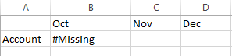
- Click Refresh.
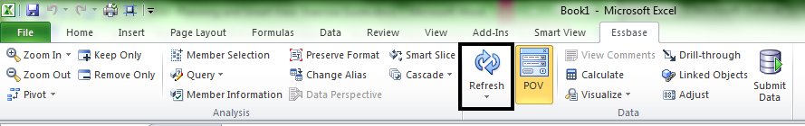
- Result:

To Zoom In and Out of Members:
- Click Account click Zoom In.
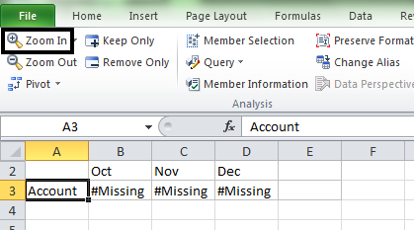
- Click Financial Account Hierarchy.
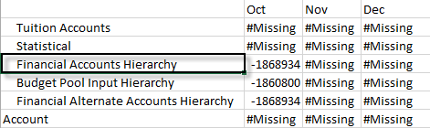
- Click the Zoom In drop-down and select Next Level.
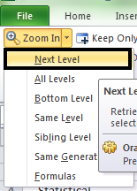

To Pivot Members:
- Click and drag Scenario from the POV to the Column of the grid.
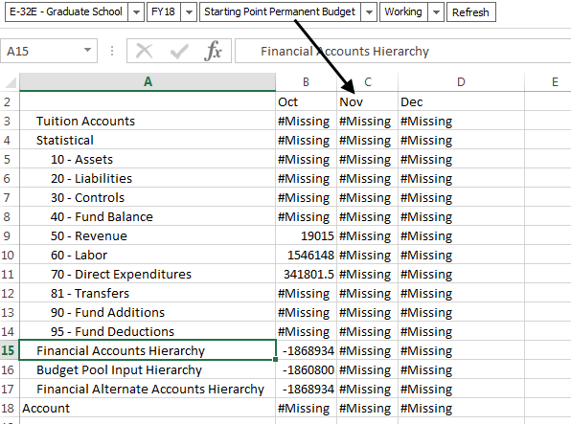
- Result: 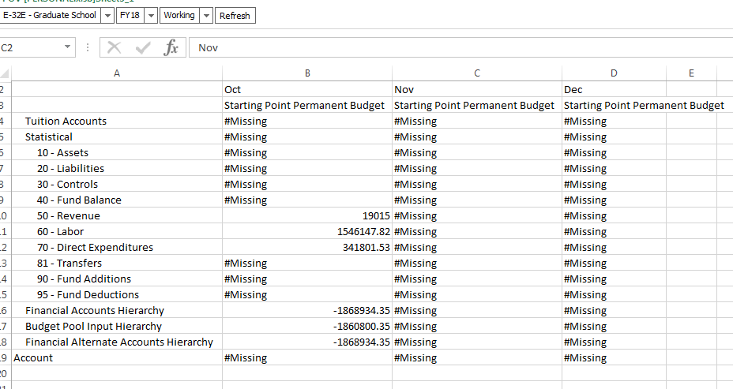
- Click cell B3.
- Click Pivot.
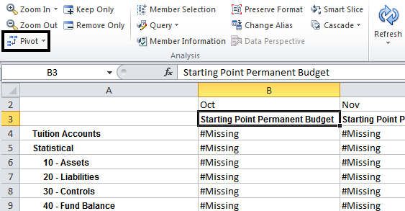
- Result:
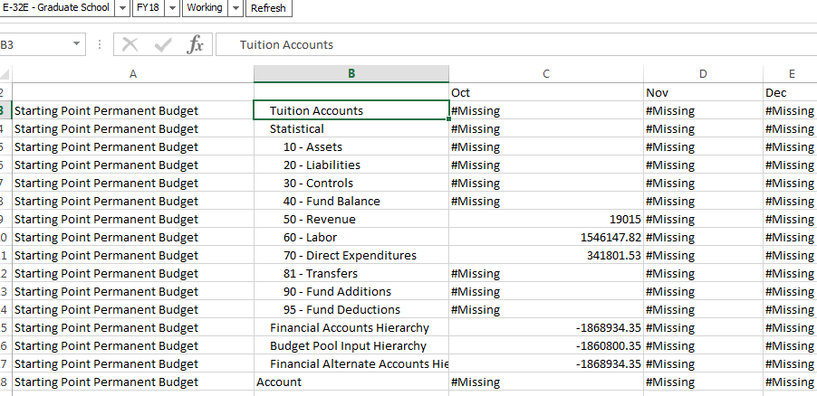
- Click cell A3
- Click the Pivot drop-down.

- Click Pivot to POV.
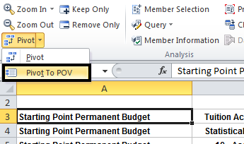
- Result:
- 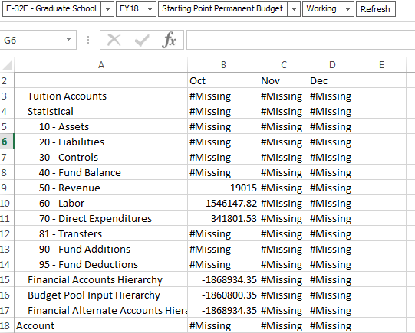

To Keep and Remove Members from the Grid:
- Click and drag to select cells A4 - A15.
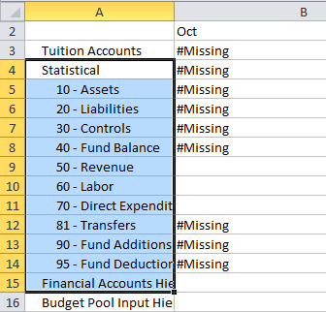
- Click Keep Only.
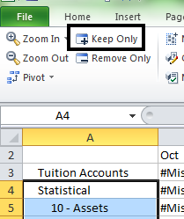
- Click cell A3 (i.e. Statistical).

- Click Remove Only.
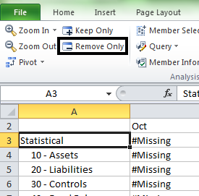

Exercise 6: Smart View Ad Hoc Additional Functionality
In this exercise users will create a query using Query Designer, format an ad hoc grid, and create a cascade report.
To Create a Query Using Query Designer:
- Click More >>.
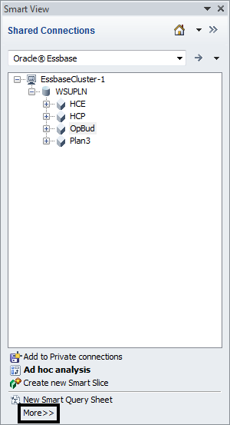

- Click Query Designer.
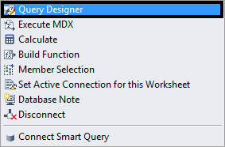
- Click Period.
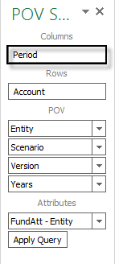
- Expand YearTotal.
- Expand Q1

- Click Add.
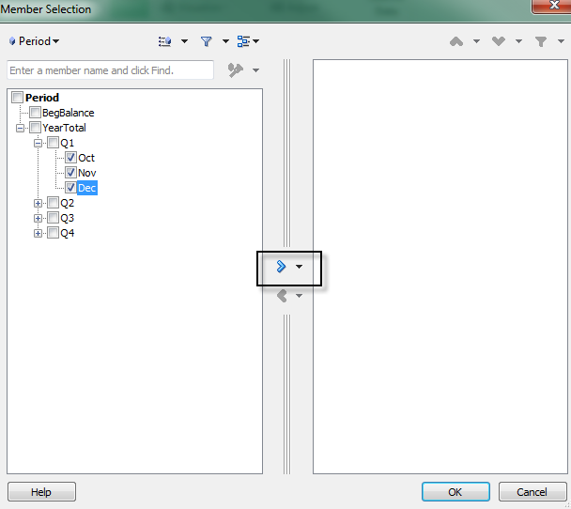
- Click OK.
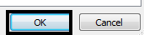
- Select member for each Dimenson:
Account: Financial Accounts Hierarchy;
Entity: E-32E;
Scenio: Starting Point Permanent Budget;
Version: Working;
Years: FY18
- Click and drag Entity to Rows.

- Result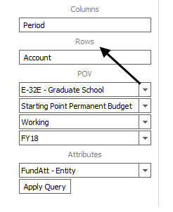
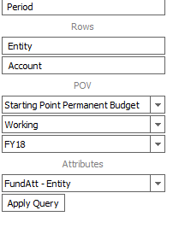
- Click Apply Query.

To Format an Ad Hoc Grid:
- Click the Smart View ribbon.
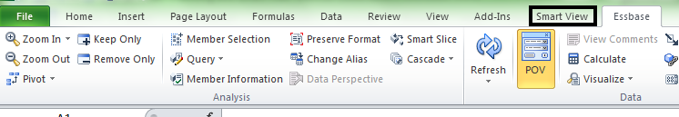
- Click Options.
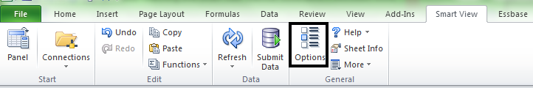
- Click Formatting.
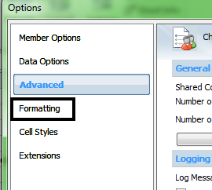

- Ensure that Use Cell Styles is enabled.
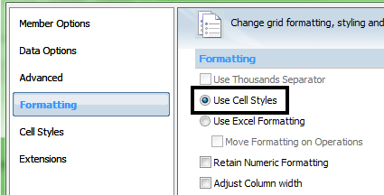
- Click Cell Styles.
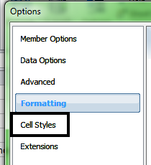
- Expand Analytic Services.
- Check Analytic Services.
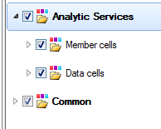

- Expand Member cells.
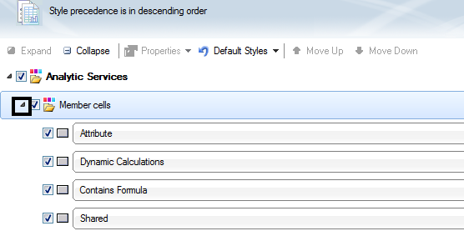
- Click Parent.
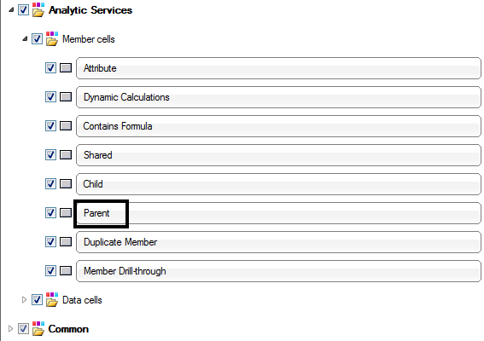

- Click Properties > Font.
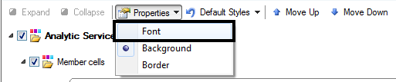
- Select Bold.
- Click OK.
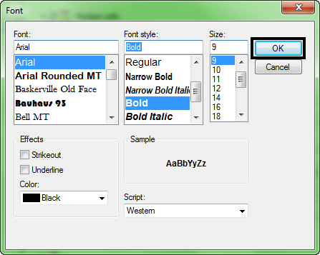
- Click OK.

To Create a Cascade Report:
- Click Essbase.
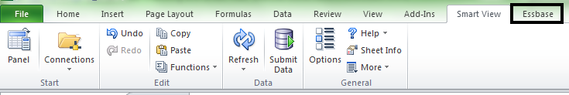
- Click Cascade.
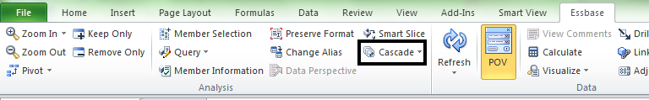
- Click New Workbook.
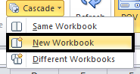
- Select FY18.

- Click Add.
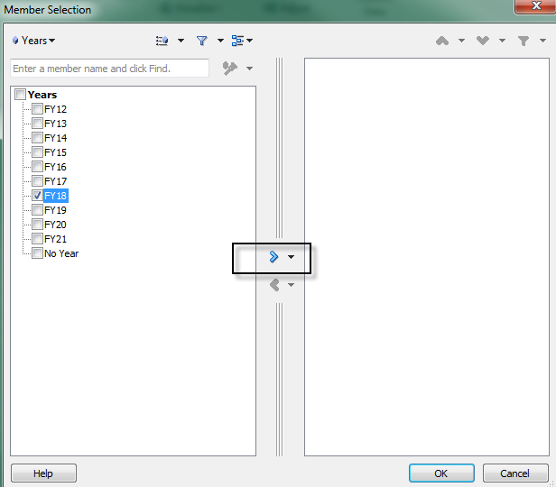.
- Click OK.

