Hyperion Planning
End User Auxiliary Fund Training

Hyperion Planning
End User Auxiliary Fund
Student Guide

Huron Consulting Group
550 West Van Buren
Chicago, IL 60607

Hyperion Planning March 2015

COPYRIGHT NOTICE
©2015 Huron Consulting Services LLC. Use and distribution prohibited except through written agreement with Huron

Table of Contents
WSU Budget Process: Current vs. Future 5
WSU Budgeting Process: Current vs Future 6
Introduction to Hyperion 7
Planning and Essbase 7
Introduction to Hyperion Planning 8
Components of WSU’s Hyperion Planning 8
Introduction to Hyperion Essbase 9
Hyperion Planning at WSU 15
WSU’s Planning Dimensions 16
Navigating Workspace 21
Defining User Preferences 25
WSU End User Task Lists 32
Task Lists Overview 33
Navigating the Task List 33
User Responsbilities 36
Budget – End User Task List 37
End User Task Lists – Auxiliary Fund Budget 41
User Responsbilities 42
Auxiliary Fund Budget Task List 43
Working with Data Forms in Planning 51
Data Forms Introduction 52
Opening Data Forms 55
Form Page Members 56
Introduction to Data Entry 57
Typing Values in Cells 59
Copying and Pasting Data 59
Refreshing and Saving Data 59
Adjusting Values by a Percentage 60
Adjusting Values Using Mathematical Operators 61
Data Form Instructions 61
Cell Comments 62
Introduction to Financial Reports 64
Financial Reports 65
Smart View 69
Smart View Overview 70
The Smart View Ribbon 70
Connecting to a Data Source 71
Introduction to Ad Hoc Analysis 72
Creating an Ad Hoc Grid 72
Changing the Point of View (POV) 77
Refreshing the Grid 79
Smart View Zoom 79
Pivoting 82
Keep Only and Remove Only 84
Query Designer 85
Substitution Variables 88
Formatting Ad Hoc Grids 89
Excel Formulas in Ad Hoc 93
Cascading Reports 94
Typing Values in Cells 96
Copying and Pasting Data 96
Support Discussion 97
Support Contacts 98

1

WSU Budget Process: Current vs. Future

WSU Budgeting Process: Current vs Future
Currently WSU utilizes various software applications to carry out the annual budget process. With the addition of the Hyperion Suite, users now have more seamless communication between processes. Below is a graphic to demonstrate the differences between the current budgeting process and the future budgeting process.

2

Introduction to Hyperion

Planning and Essbase

Introduction to Hyperion Planning
Hyperion Planning is a web-based planning solution that drives collaborative, event-based operational planning processes throughout the organization for a wide range of financial and operational needs. Planning is an all-in-one tool for the end-to-end and closed-loop planning process that drives continuous business improvement. The Hyperion Planning application does not replace the Cognos tool in the WSU budgeting process. Planning provides the ability for all front-line managers to communicate the appropriate course of action to take and allows the budget holders to collaborate so that the planning process is streamlined and efficient.
Sitting on top of Hyperion Essbase provides Planning with a multidimensional data structure that allows for flexibility in both the collection of data and its analysis.

Components of WSU’s Hyperion Planning
The following Hyperion products are included in WSU’s Planning Environment:
- Hyperion Planning Web Client
- Hyperion Workspace
- Hyperion Essbase Database
- Hyperion Financial Reporting
- Hyperion Smart View for Office

Hyperion Planning Web Client
The Planning Web Client is the primary interface to Hyperion Planning and is used by all levels of Planning users. The Web Client is used by both the financial and business groups to enter and submit data, run calculations and manage the planning process.

Hyperion Workspace
Workspace provides a single business performance management interface that enables users to access the Planning Web Client and Hyperion Financial reports.

Hyperion Essbase
Planning uses Essbase to store the dimension hierarchies and consolidated data. It uses this information to create the necessary Essbase databases and security privileges for user’s application. When users enter data into a Planning application, it is stored in the Essbase databases created for the application.

Hyperion Financial Reporting
Hyperion Financial Reporting Studio is used to create financial reports that run against user’s Hyperion Planning application. Hyperion Financial Reporting uses a 3-tier architecture that consists of a database server, a web application server, and a Windows client for report creation and administration. Reports are viewed through the Workspace.

Hyperion Smart View for Office
With Smart View, users can run ad hoc queries to view and manipulate a data grid to display dimension and members to specifications.

Introduction to Hyperion Essbase
Essbase is a multidimensional database server optimized for planning, analysis and management reporting applications. Planning uses Essbase to store dimension hierarchies and consolidate data. Plan data entered into the Planning application is stored in the Essbase database.

Overview
Dimensions are the actual descriptors of the base elements that describe and hold data. Years, Scenarios, Version and Accounts are all examples of dimensions.
Within each dimension, the individual elements are called members. E-04AA is a member of the Entity dimension and Working is a member of the Version dimension.
Dimensions defined in the WSUPLN Planning application are then created as dimensions in the Essbase outlines and databases.

Dimension Hierarchies
Members of dimensions are arranged in hierarchies. These hierarchies create relationships between the members that reside on the various levels of the hierarchy.
Upper-level members are called parent members and the members immediately below them are called their children. All members below a parent are called descendants and the bottom-level members are called base members.

Metadata
Metadata describes the data values in a database. Metadata includes dimension names, member names, properties and security.
For example, the member name computer expenses, describes the data related to computer expenses and the member name March describes the data related to March. Therefore, March computer expenses, identifies the Metadata for computer expenses for the month of March.

Multidimensional View
Hyperion Essbase data is stored in a cube where the faces of the cube represent dimensions. With a multidimensional cube, each face represents a dimension. For instance, a dimension might be Years, Entity or Account.
Dimensions are the highest level and within each user may have hierarchies. For example, within the Year dimension, users may have quarters and months as a hierarchy.

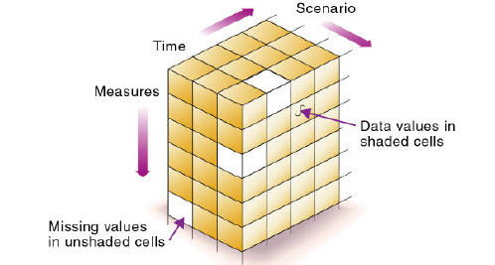

Drill Down
Drilling down is the process of retrieving progressively detailed data from a dimension by expanding a parent member to reveal its children. The expansion can reveal hierarchical relationships, such as those between a parent entity and its child entity, a parent account and a child account or a summary time period and a base time period. For example, drilling down can reveal the hierarchical relationships between a year and quarters or between a quarter and months.
The following example drills down on the Period dimension to reveal the YearTotal Member and BegBalance members that are contained within. Drilling down on YearTotal reveals the four quarters that make up that year. Drilling down on a quarter reveals the three months that make up each quarter.
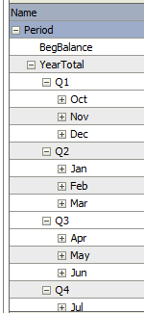

Essbase Terminology
The following table describes the common terminology used in Essbase.
Term | Description
Outline | The representation of the relationships among the members in the database
Dimension | A perspective on the data being analyzed
Member | Discrete component making up a dimension
Attribute Dimension | Dimension tagged as an attribute that helps describe another dimension

Identifying Member Branches – Families
The following terms describes the common family relationship terms used in Essbase:
Term | Description
Dimension | The top most members of an outline
Parent | A member that has at least one child below it
Child | A member that has a parent immediately above it
Sibling | A child member at the same branch level as another child member with the same parent
Ancestor | Any member in a branch above a member
Descendants | Any member below a parent

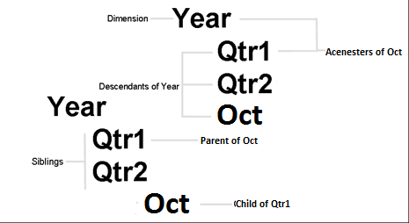
As the above depicts, Year is the dimension. Qtr1 and Qtr2 are siblings and they are also children of Year. Qtr1 is the parent of Oct. The Qtr1, Qtr2 and Oct are all descendants of Year. Qtr1 and Year are ancestors of Oct. However, note that Qtr2 is not an ancestor of Oct since Oct and Qtr2 are on different branches of the Year hierarchy.

Identifying Member Branches – Generations
The term generation refers to a member’s location within an outline from a top down perspective. The generation number identifies the branch on which the member lies in relation to its distance from the dimension name.
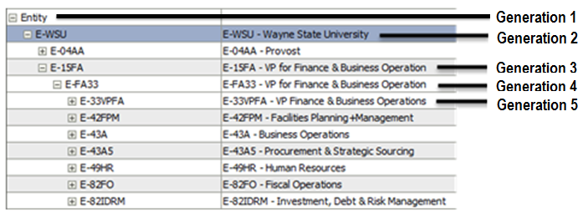
Term | Definition
Generation | The root member is Generation 1. When referring to generations, the structure begins at the root, moves to the branches and ends with the leaf nodes. Generations move from the root toward the leaf node
Leaf | Members that have no children

Identifying Member Branches – Levels
A member’s location within the outline can also be referred to by levels. This is a reference to the member’s location within an outline from a bottom-up perspective. The leaf node members are designated Level 0. The levels increase moving up to the dimension name.
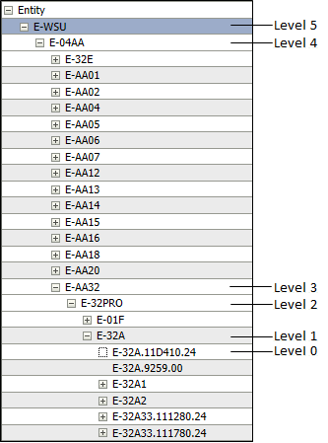

3

Hyperion Planning at WSU

WSU’s Planning Dimensions
Planning allows users to set up to three standard plan types in an application. For each plan type created, Planning creates an Essbase database. When users create the account, entities and other dimensions of the application, users associate them with a plan type. This allows users to create databases that contain dimensions and data that are relevant to each plan type and allows for optimal application design, size and performance. Data can be shared between plan types as needed.
Within the Planning application, there is the WSUPLN. The OpBud plan type has the following dimensions: Accounts, Entity, Scenario, Version, Period and Years.

Account
The Account dimension consists of:
- System Members
- Unspecified Account
- Human Capital Planning Accounts
- LaborAccts
- Revision Properties
- Segment Information
- Segment Descriptions
- Tuition Accounts
- Statistical
- Financial Accounts
- Budget Pool Input
- Financial Alternate Accounts

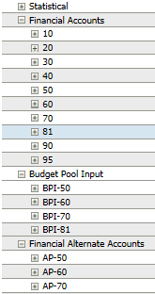
- Note: Some members in the Account dimension hierarchy are currently not being used. These members include: System members, unspecified account, human capital planning accounts, laboraccts, revision properties, segman information, segment descriptions, tuition accounts, and statistical.

Period
The Period dimension relates to the Months that comprise WSU’s fiscal year (October – September). This dimension allows for Year-to-Date and Quarter-to-Date analysis.
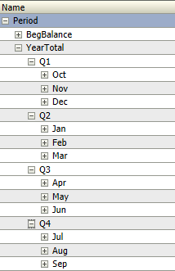

Years
Fiscal Years start in FY12 and continue through to FY22. Historical data has been loaded to the WSUPLN plan type starting with 2012.
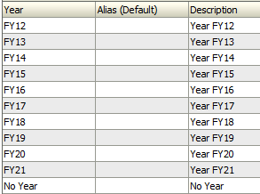

Scenario
The Scenario dimension is used to describe the type of data being used. Scenarios include: Actual, Projection, Revised Budget, Final Budget, Variances, ProjCalcs, Balance, Encumbrances, Budget Reserves and Final_FTE_Budget.
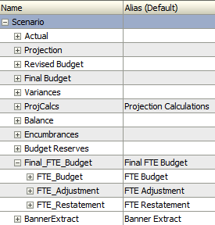

Version
The Version dimension is used to separate different “snapshots” of the annual plan and budgets. Actual and finalized annual plan numbers are stored in the “Final” version and are not available for editing without Administrator intervention. The “Working” version is used to create a draft of the annual plan and is the primary version used for updates to the budget by end users. The “BudgetOffice” version is the primary version used for updates to the budget by Budget Office users.
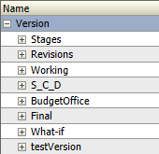

Entity
The Entity dimension is a hierarchical representation of WSU entities. The entity dimension is a concatenation of Org, Fund and Prog, similar to indexing in Banner. The primary hierarchy represents the Organizational Attribute dimensions will be defined later. Each entity is tagged for Fund and Prog reporting.
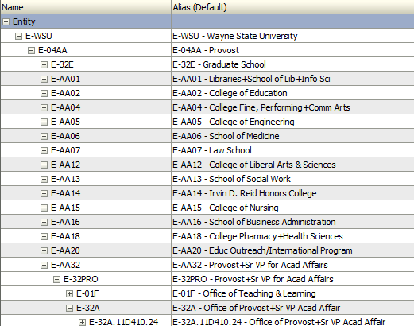

Navigating Workspace
Workspace allows users to access the Planning application and Financial Reports. The Home Page is the launching point for all applications and reports. The Home Page displays recently opened documents, Workspace Pages, and Quick Links to Favorites and Applications.
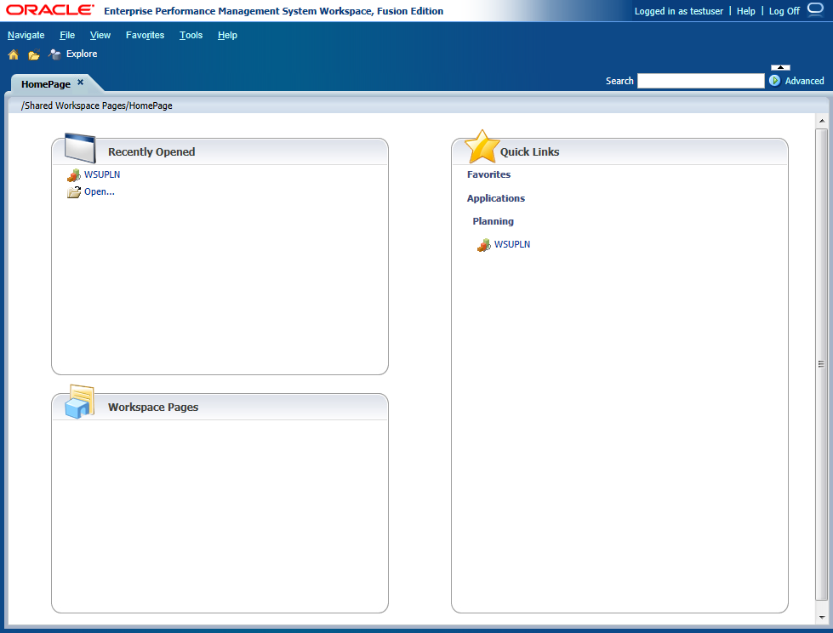

- To Log onto Workspace:
- Start Mozilla Firefox.
- Note: Must be logged into the WSU VPN to access the Hyperion Workspace.
- Enter the following URL: https://hypwebpp.ad.wayne.edu/workspace/index.jsp.
- Press Enter.
- Enter the Username and Password.
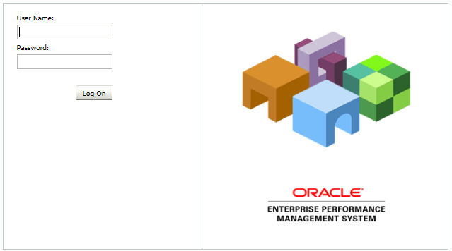
- Click Log On.
The Workspace Home Page displays.
- Check the Workspace Pages area to view new alerts.

Recently Opened Documents
The Recently Opened documents area displays the nine most recently used items. An icon representing the item type displays next to the items name. The item name serves as a link for opening the item. At the bottom of the list is an Open link which allows users to open new items.
Planning
Essbase
Financial Reports

Workspace Pages
The Workspace Pages area lists up to four My Workspace Pages and four Shared Workspace Pages. My Workspace Pages are workspace pages users can customize. Shared Workspace pages are workspace pages that are stored in a system folder and shared among a group of users.

Quick Links
The Quick Links area displays links to the Planning applications as well as links to Financial Reports that have been added to the favorites list.
- To Open the Planning Application:
- Select File > Open > Applications > Planning > WSUPLN.
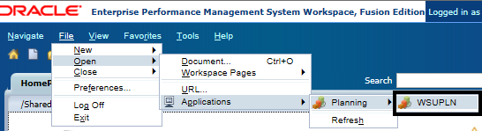

The Newly opened items open. When returning to the Home Page, they will be listed in the Recently Opened area.
- Note: WSU decided to use task lists for reporting. For reporting, the Budget Office can use these steps or the Planning task list; however, end users only access the reports via the Planning task list.
- To Add Items to Favorites:
- Open the document to save as a favorite item.
- Select Favorites > Add to Favorites.
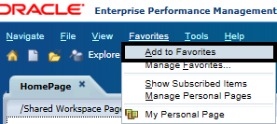
The item can then be seen in the Favorites menu at next log in.

Defining User Preferences
The Hyperion Planning Application includes a Preferences page for end users to set various settings for the Hyperion Planning Web Client. The Preferences page displays differently for an administrator versus an end user. These Preferences will need to be set before working in the Application.
- To Access the Preferences for the Planning Application:
- Open the WSUPLN application.
- From the main menu, select File > Preferences.
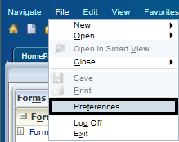
The Preferences dialog box displays.
- Click Planning.
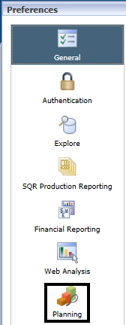
The Planning preferences display.

The Planning Preferences Page
The Planning preferences page includes four tabs:
- Application Settings
- Display Options
- Printing Options
- User Variable Options

The Application Settings tab
From the Application Settings tab, WSU users can select the alias tables to use to display member and dimension names if alternate names or aliases have been assigned to Account, Entity and user-defined dimensions and members.
- To Select the Alias Table for Displaying Names:
- Select the Application Settings tab.
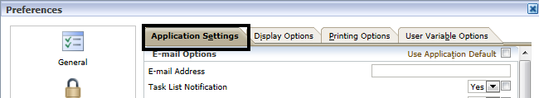
- In the Alias Setting area, select the desired setting from the drop-downs.
- Click Save.
- Click OK.

The Display Options tab
From the Display Options tab, WSU’s users can complete the following tasks:
- Change how numbers display on data forms
- Set aspects of page display
- Remember the most recent page visited
- Enable warning for large data forms
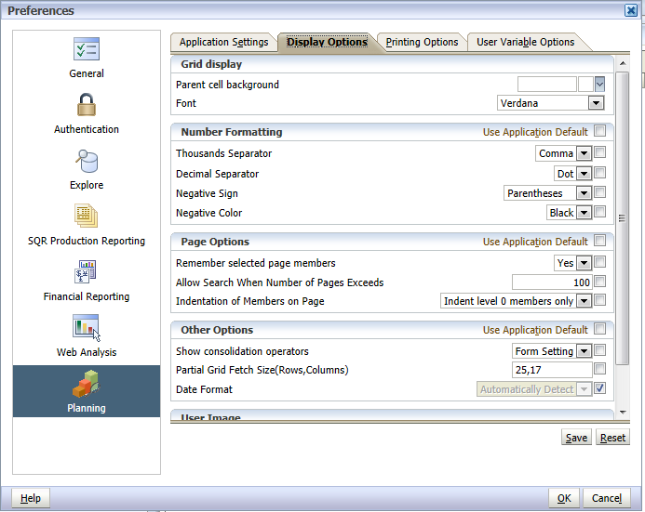

Formatting Numbers
The choices in the Number Formatting section will override the settings for individual currencies that the administrator set up. Users can control the display for the following:
- The thousands separator
- The decimal separator
- The display of negative numbers
- The display color for negative numbers

Formatting selections take effect when leaving the data cell.
- Note: If selecting a setting other than Use Default Setting for either the thousands separator or the decimal separator, then change both separators from the Use Default Setting option.
- To Change the Formatting of Numbers:
- Select the Display Options tab.
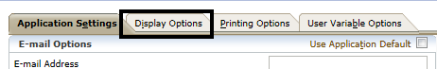
- In the Number Formatting section, select the options for formatting numbers.
- Click OK.

Page Options
The most recently used dimension members from both the Page and POV of the last form used are remembered and compared to that of each form selected. If there is a match, that member name displays in the drop-down list of the new form selected.
The number of members can be specified that enable a search facility on the page drop-down lists on the data entry page by entering a value in the Allow Search When Number of Pages Exceeds box.
Users can set how displayed members are indented on the Page drop-down. The following options are available:
Option | Description
Indent level O members only | Indents only the bottom-most members (the default)
Indent based on hierarchy | Indents members based on their hierarchy level
Do no indent | Displays members as a flat, sequential list
- To Set Page Options:
- Select the Display Options tab.
- Select Remember the Last Page Selected.
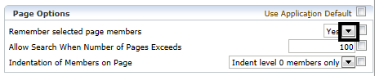
- Select Yes.
- Enter a data value in the Allow Search When Number of Pages Exceeds area.
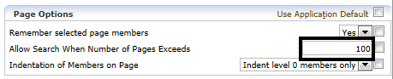
- From the Indention of Members on Page drop-down, select how the Page members should display.
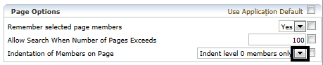
- Click OK.

Printing Options Tab
Printing options for data forms are set by the form designer when the data form is created. Users can accept the default settings or set their own options for creating PDF files.
Users set printing options directly from the data form when they are ready to print or they can use Preferences to set printing options. The options set from the Preferences page apply to all data forms to which users have access rights. The following print options can be set:
Option | Action
Format Data | Applies to number format settings from the data form
Apply Precision | Applies the data form’s precision settings to the displayed data. If the data form displays high precision numbers, consider limiting precision in the PDF file.
Include Supporting Detail | - Normal Order: inserts the Supporting Detail in the same order in which it displays in the Supporting Detail page, after the member that it is associated with.  - Reverse Order: inserts the Supporting Detail before the member it is associated with, and the Supporting Detail entries are reversed. Supporting Detail for children is displayed above their parents, and the order of siblings is preserved.
Show account annotations | Shows the data form annotations. If the data form designer enables account annotations, this option displays the annotations.
Show comments | Shows associated text notes.
Show attribute members | Shows attribute members that are assigned to the data form.
Show currency codes | If the data form supports multiple currencies per entity, shows currency codes.

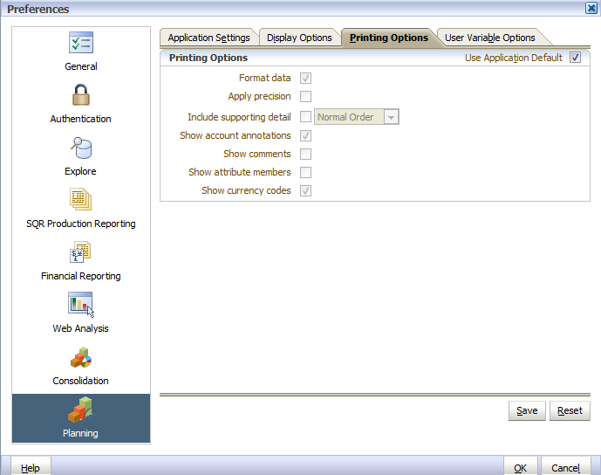

5

WSU End User Task Lists

Task Lists Overview
Task lists provide a powerful method of managing and guiding end users through a planning process by providing lists of specific activities to complete within and outside of Hyperion Planning. An organization plan or forecast may require end users to perform multiple activities, some of which may be performed infrequently by end users. Task lists provide guidance in completing these activities.
When completing a task list, the user is taken through a step-by-step wizard. The wizard guides users through each step. Not only are individual steps mapped out, but the sequence and end dates of steps are identified.
After users complete the requirements for a task, users can mark the task as complete. After users mark a task as complete, the alert changes to a date stamp that shows the date and time of completion.
If a task has dependent tasks, users must complete the dependent tasks before completing the primary task.

Navigating the Task List
Once logged into the Planning application, expand My Task List and work down the list in order to ensure that all necessary steps have been completed.
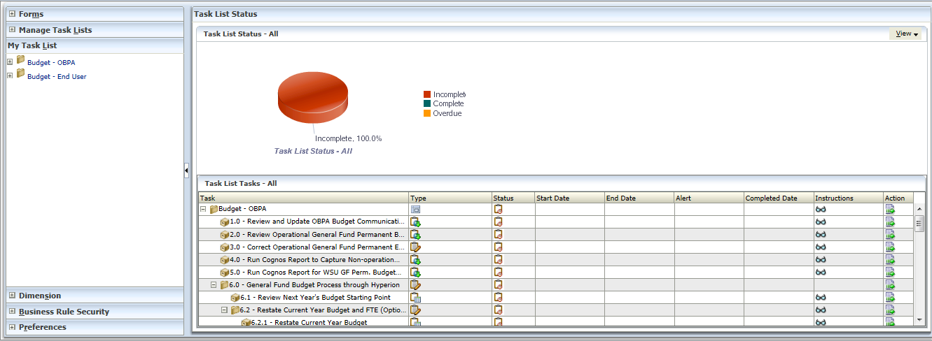

- To Open and Complete a Task:
- Expand My Task List.
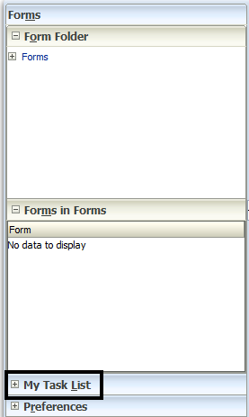
- Expand a Task List.
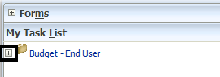

- Click a Task.
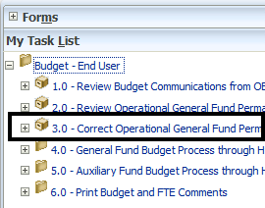
- Click Task Instructions.
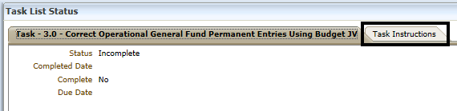
- Perform the task.
- Click Complete.
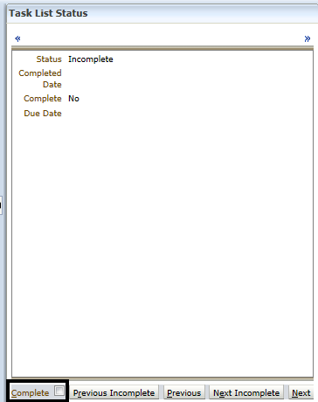

User Responsibilities
In the task list there are various items that users must be aware of in order to complete the WSU Budgeting process appropriately. Below are items that users need to be aware of when completing their task lists.

Reduction Targets
The OBPA Budgeting Office will provide users with the reduction targets at the organizational level. Reduction targets are a top level dollar amount to reduce the budget.

Cell Comments
When changes are made to the budget, users are expected to add a comment to the cell to communicate to the OBPA the change. Every dollar change needs a comment for situations of:
- Reduction
- Cross Entity Reallocation
- Labor reductions

Labor Reductions
Every labor reduction requires a comment that includes the position number except in certain instances. The instance in which a position number is NOT need is:
- Grad Assistants
- Part-time employees
- Student Assistants

Excel Files
Some of the task list items include opening an Excel document. The Excel document is meant to be used as an input checklist for users. Users can input data into the Excel document prior to inputting data into the Hyperion Planning application.

Financial Reports
When users select a task that opens a Financial Report, users must select an appropriate Entity before the Financial report will open.

Budget – End User Task List
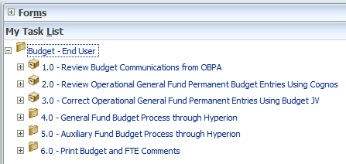

1.0 Review Budget Communications from OBPA
The 1.0 Review Budget Communications from OBPA will redirect users to http://budget.wayne.edu/Budget.aspx . This URL has instructions on how to complete their budget along with budget guidelines for the current budget year.

2.0 Review Operational General Fund Permanent Budget Entries Using Cognos
The 2.0 Review Operational General Fund Permanent Budget Entries Using Cognos task will direct users to run a Cognos report to see all operational general fund permanent budget entries entered in banner up to yesterday for selected general fund(s) in the current fiscal year.

3.0 Correct Operational General Fund Permanent Entries Using Budget JV
The 3.0 Correct Operational General Fund Permanent Entries Using Budget JV task will open an excel file called JV_fmt_rvsd.xls. This document is used to make corrections through JV as needed. JV needs to be entered in Banner by April 30. The Excel document can be used for users to manipulate numbers to determine best fit prior to data entry into the form. The users must know the entity and must type it’s into the form.
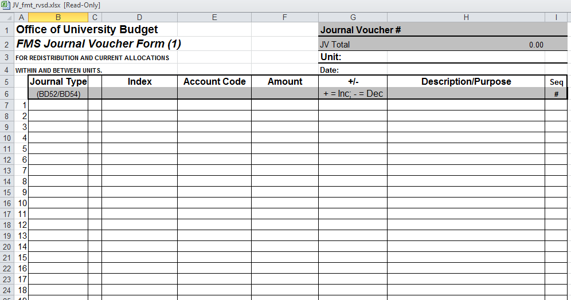
- Note: Be sure to save the Excel files locally on the user computer prior to making any edits.

4.0 General Fund Budget Process through Hyperion
The 4.0 General Fund Budget Process through Hyperion task contains all tasks relating to General Fund Budget end users. The tasks include:
- 4.1 Review Next Year’s Budget Starting Point
- 4.2 Budget Data Entry and FTE Preparation Worksheet (Optional)
- 4.3.0 Next Year’s Budget
- 4.4 Enter FTE
- 4.5 Review Budget and FTE Entries
- 4.6.0 Fund Reporting

Each of these tasks will be discussed further in the End User - General Fund Budget Training Guide.
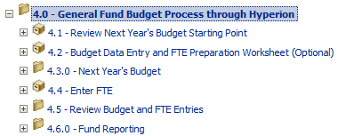

5.0 Auxiliary Fund Budget Process through Hyperion
The 5.0 Auxiliary Fund Budget Process through Hyperion task contains all tasks relating to Auxiliary Fund Budget end users. The tasks include:
- 5.1 Review Next Year’s Budget Starting Point
- 5.2 Budget Data Entry and FTE Preparation Worksheet (Optional)
- 5.3 Next Year’s Budget
- 5.4 Enter FTE
- 5.5 Review Budget and FTE Entries
- 5.6 Fund Reporting

Each of these tasks will be discussed further in the End User Task Lists – Auxiliary Fund Budget...
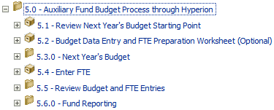

6.0 Print Budget and FTE Comments
The 6.0 Print Budget and FTE Comments task contains all tasks relating to printing comments. The tasks include:
- 6.1 Print Budget Comments
- 6.2 Print FTE Comments

6.1 Print Budget Comments
The 6.1 Print Budget Comments task list opens a report that shows all comments that were added for budget entries.
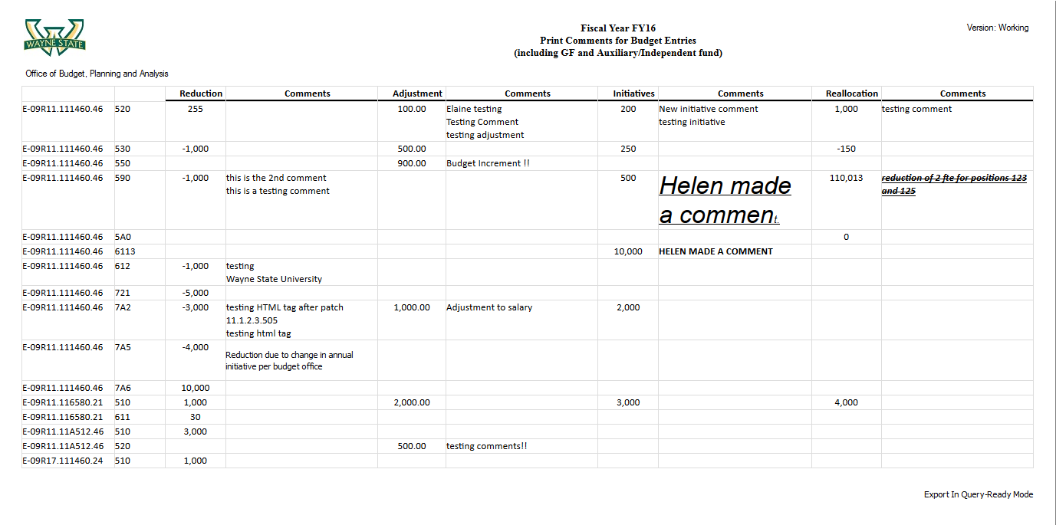

6.2 Print FTE Comments
The 6.2 Print FTE Comments task list opens a report that shows all comments that were added for FTE entries.
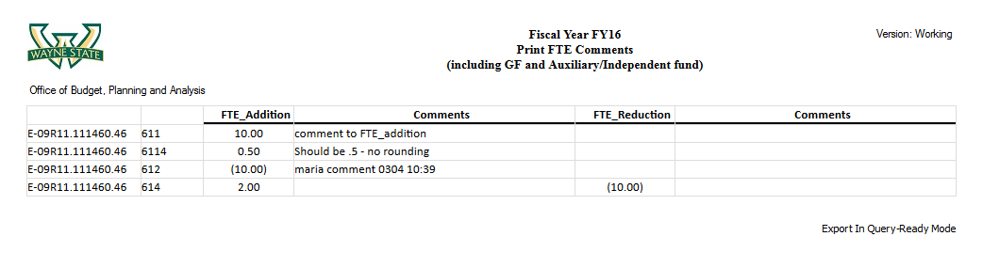

6

End User Task Lists – Auxiliary Fund Budget

User Responsibilities
In the task list there are various items that users must be aware of in order to complete the WSU Budgeting process appropriately. Below are items that users need to be aware of when completing their task lists.

Reduction Targets
The OBPA Budgeting Office will provide users with the reduction targets at the organizational level. Reduction targets are a top level dollar amount to reduce the budget.

Cell Comments
When changes are made to the budget, users are expected to add a comment to the cell to communicate to the OBPA the change. Every dollar change needs a comment for situations of:
- Reduction
- Cross Entity Reallocation
- Labor reductions

Labor Reductions
Every labor reduction requires a comment that includes the position number except in certain instances. The instance in which a position number is NOT need is:
- Grad Assistants
- Part-time employees
- Student Assistants

Excel Files
Some of the task list items include opening an Excel document. The Excel document is meant to be used as an input checklist for users. Users can input data into the Excel document prior to inputting data into the Hyperion Planning application.

Financial Reports
When users select a task that opens a Financial Report, users must select an appropriate Entity before the Financial report will open.

Auxiliary Fund Budget Task List

5.0 Auxiliary Fund Budget Process through Hyperion
The 5.0 Auxiliary Fund Budget Process through Hyperion task contains all tasks relating to Auxiliary Fund Budget end users. The tasks include:
- 5.1 Review Next Year’s Budget Starting Point
- 5.2 Budget Data Entry and FTE Preparation Worksheet (Optional)
- 5.3.0 Next Year’s Budget
- 5.4 Enter FTE
- 5.5 Review Budget and FTE Entries
- 5.6.0 Fund Reporting

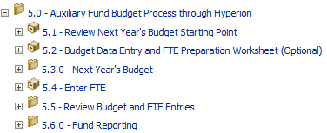

5.1 Review Next Year’s Budget Starting Point
The 5.1 Review Next Year’s Budget Starting Point task opens a form for users to enter data for the Permanent Auxiliary Fund Budget. The Starting Point Permanent Budget is a summary of the CY Original Budget, Technical CY Adj, and Compensation CY Adj by entity (combination of organization, fund, and program).
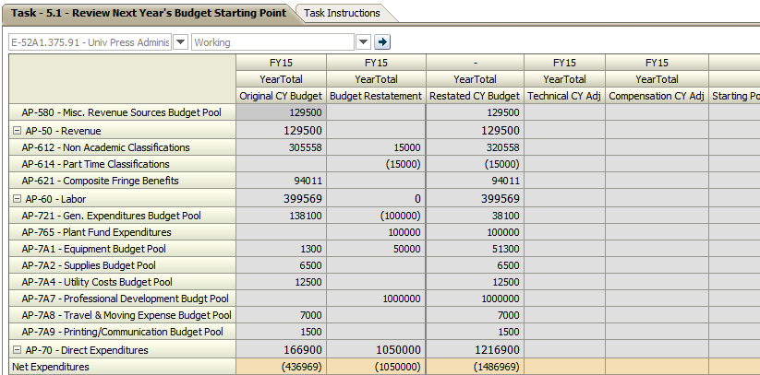

5.2 Budget Data Entry and FTE Preparation Worksheet (Optional)
The 5.2 Budget Data Entry and FTE Preparation Worksheet (Optional) task opens an Excel document called Budget Data Entry and FTE Preparation Form – Auxiliary Fund. The Excel document is to assist users in data entry into the Planning forms. Users must know the entity and type the name into it in the form.
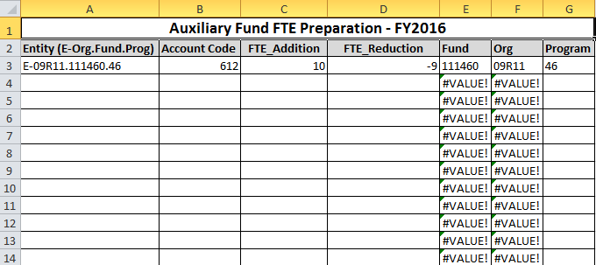

5.3.0 Enter Next Year’s Budget
The 5.3.0 Next Year’s Budget task holds the following two tasks:
- 5.3.1 Enter Next Year’s Budget
- 5.3.2 Restate Current Year FTE

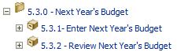

5.3.1 Enter Next Year’s Budget
The 5.3.1 Enter Next Year’s Budget task opens a form that is used for the auxiliary fund budget. Users to enter data in the following columns:
- Reduction: reduction of the budget should be entered as a negative value.
- Adjustment: changes to previous year’s budget allocations which will include permanent transfer between SCD.
- Initiatives: approved new program changes that will be entered by OBPA.
- Reallocation: changes between account codes and across entities within their school/college/division and should net to zero.

Data can only be entered in the bottom half of the form. The data entered in the bottom half of the form will automatically update the top half of the form, once Save is clicked.
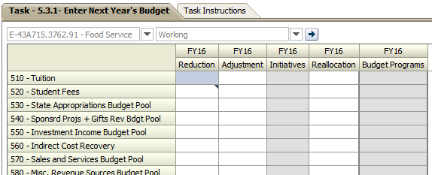

5.3.2 Review Next Year’s Budget
The 4.3.1Enter Next Year’s Budget task opens a form that is used to review next year’s auxiliary fund budget.
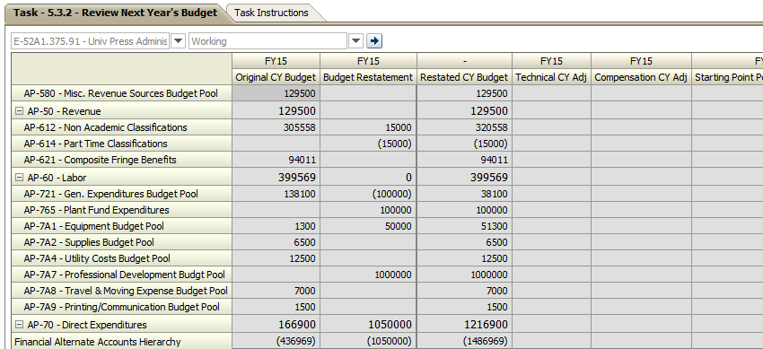

5.4 Enter FTE
The 5.4 Enter FTE task opens up a form for users to enter auxiliary fund FTE data.
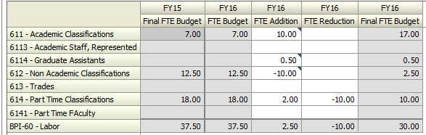

5.5 Review Budget and FTE Entries
The 5.5 Review Budget and FTE Entries task list contains all tasks relating to reviewing budget and FTE Entries. The tasks include:
- 5.5.1 Review Budget Entries
- 5.5.2 Review FTE Entries
- 5.5.3 Review Budget and FTE Summary
- 5.5.4 Budget Detail

The reports that open require that users select an Entity prior to viewing the financial report. Users must note that the select will have to be made every time the report is opened.
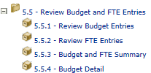

5.5.1 Review Budget Entries
The 5.5.1 Review Budget Entries opens a financial report for users to review the auxiliary fund budget entries. Users are prompted to select an entity.
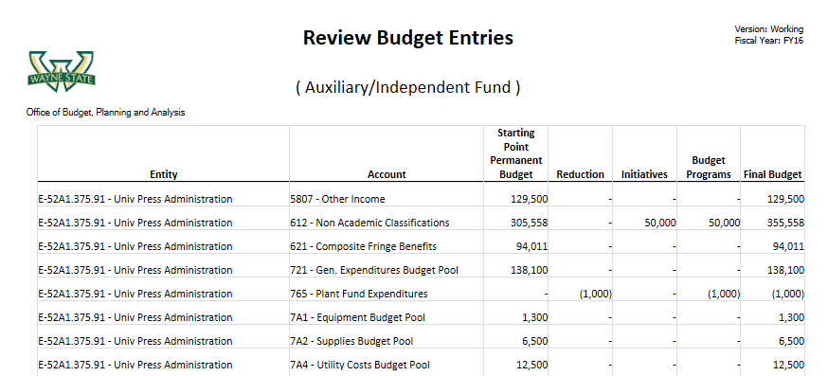

5.5.2 Review FTE Entries
The 5.5.2 Review FTE Entries opens up a financial report for users to review the auxiliary fund FTE entries. The users are prompted to select an entity.
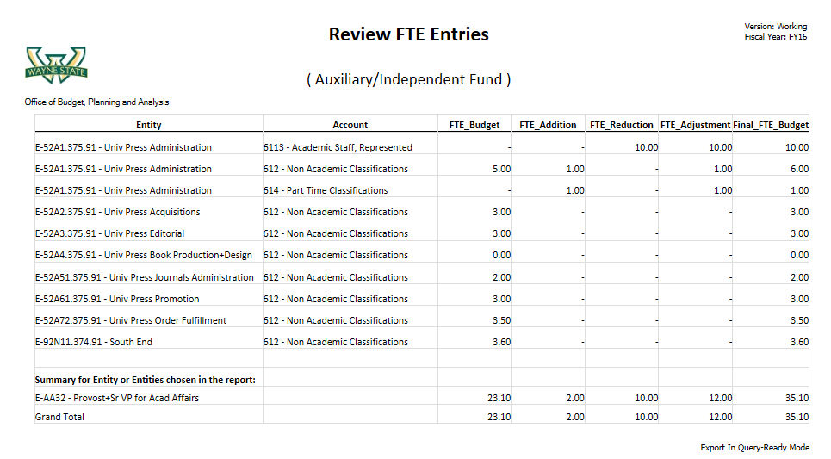

5.5.3 Budget and FTE Summary
The 5.5.3 Budget and FTE Summary task opens a financial report for users to review the auxiliary fund budget and FTE summary. Users are prompted to select an entity.
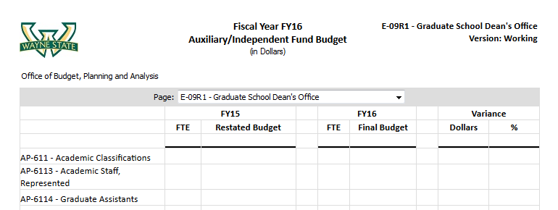

5.5.4 Budget Detail
The 5.5.4 Budget Detail task opens a financial report for users to review the auxiliary fund budget details. Users are prompted to select an entity.
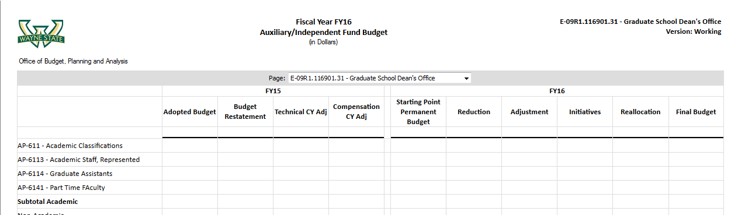

5.6 Fund Reporting
The 5.6 Fund Reporting task holds the following two other tasks:
- 5.6.1 Budget and FTE Summary by Fund
- 5.6.2 Budget Detail by Fund

5.6.1 Budget and FTE Summary by Fund
The 5.6.1 Budget and FTE Summary by Fund task opens up a financial report for auxiliary/independent fund budget and FTE Summary by fund.
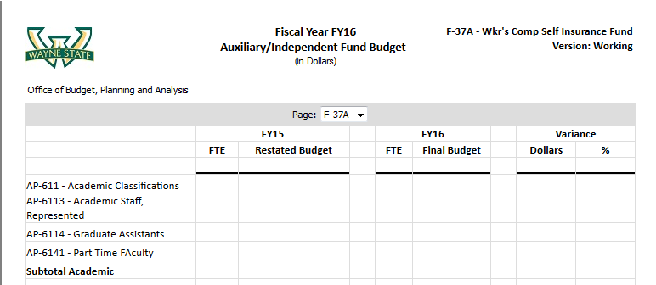

5.6.2 Budget Detail by Fund
The 5.6.2 Budget Detail by Fund task opens up a financial report for auxiliary/independent fund budget detail by fund.
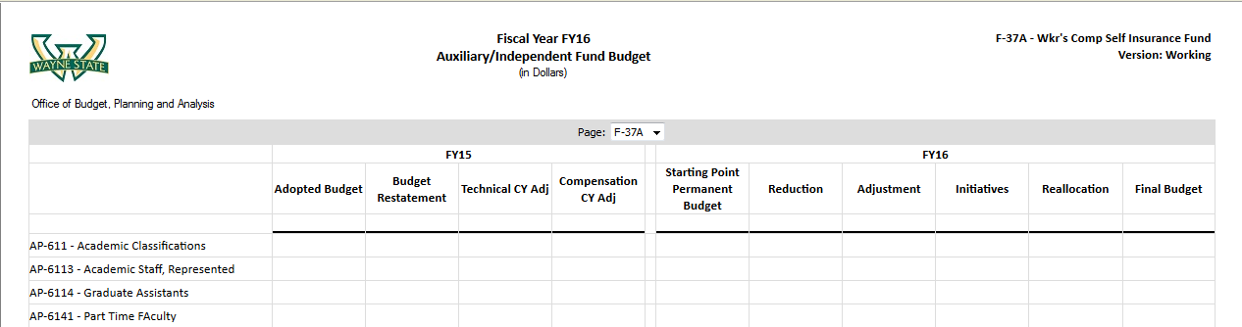

7

Working with Data Forms in Planning

Data Forms Introduction
The Hyperion Planning Web Client can be used to enter plan data into data forms. These are the data entry tasks that can be performed:
- Type data directly into cells on a data form
- Increase or decrease existing data by a percentage, using Adjust

The View Pane
The View Pane lists the data forms, task list folders and preferences that are set up for the application. After selecting a task list folder, a data form or report is displayed in the content area.

The Content Area
Data forms and reports are displayed in the content area of the Web Client. A data form provides an intuitive layout to work with the data in the plan from the web. Data forms displayed in the content area reflect the access rights to the dimension members on the data forms. Cells in which users can enter data are white. Cells that are read-only are shaded light blue/gray.

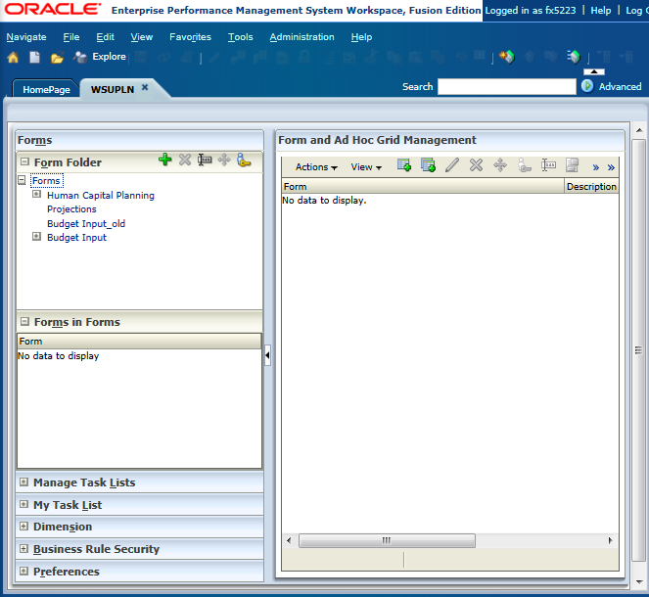
View Pane
Content Pane

The Data Form Toolbar
The data form content pane toolbar contains icons for quick access to data form functionality.
Save data values
Refresh data to previous values
Print the form data
Adjust cell values to be increased or decreased by a specified percentage
Launches the grid spread tool
Launches the cell text dialog box
Locks the selected cells or unlocks previously locked cells
Launches the supporting detail entry form
Launches the Document Attachments dialog box
Opens the Instructions for the current data form
Opens the data form in Excel with the Smart View Excel Add-in

Data Cell Right-Click Menu Options
Right-clicking on a data cell provides users with a second way to access many of the data entry options that are available on the toolbar as well as a few additional options.
- Note: Right-clicking a row or column header allows users to change the row and column dimension members that display on the data form. We will discuss these options later in this chapter.
The right-click menu offers the following additional options:
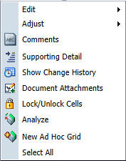 | 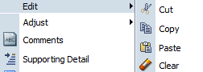

Term | Definition
Add Dimension Members | Displays the Runtime prompts dialogs box which allows selecting dimension members to add to the current data form  Note: Right-clicking a dimension member name also gives the option to remove that account from the data form.
Edit | Allows cutting, copy, paste and clear data from a data cell
Adjust | Allows accessing of the Adjust Data and Grid Spread dialog boxes
Show Change History | Allows reviewing of changes that have been made to the data cell

Opening Data Forms
After logging on to Workspace and opening a Planning application for the first time, the Select Data form page is displayed. This page is the access point to all tasks performed in Planning. From this page, users can navigate to the data forms needed to prepare the budget.
- To Open a Data Form:
- From a task list, click a task that contains a form.
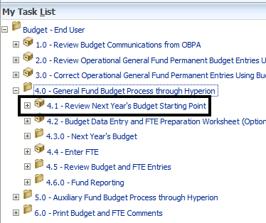

Form Page Members
The page axis lets users set up combinations of members that may span dimensions so users can work with data in smaller, logical views. Each item on the page axis can have members selected from one or multiple dimensions. Users see only members to which they have access. Users specify any number of page drop-down lists, and select members using relationship functions or attributes. Users can then switch among member sets to work with by selecting them from the page axis.
- Note: Users are not to change the Version page member for any of the forms. Budgeting Office users only can enter data in the BudgetOffice version, and End Users only can enter data in the Working version.
- To Change a Form’s Page Members:
- Open a form.
- Click a dimension page drop-down.
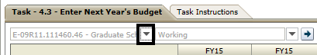
- Select a member.
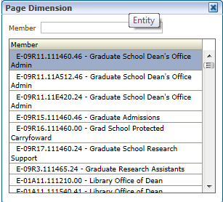
- Click Go.
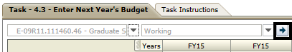

Introduction to Data Entry
Data was entered into the cells of a data form at the intersection of rows and columns. White, non-shaded cells are open to enter data into them, while shaded cells are read-only. If data exists, it is displayed in the cell and can be typed over. If data does not exist for the cell, the cell displays the text #MISSING and a numeric value can be entered.
Cells display the data for the selected members. Background colors in the cell are used to indicate status:
- White: default; data can be entered into these cells
- Yellow: ”dirty” cells, whose values changed but are not yet saved
- Light blue/Gray: read-only cells
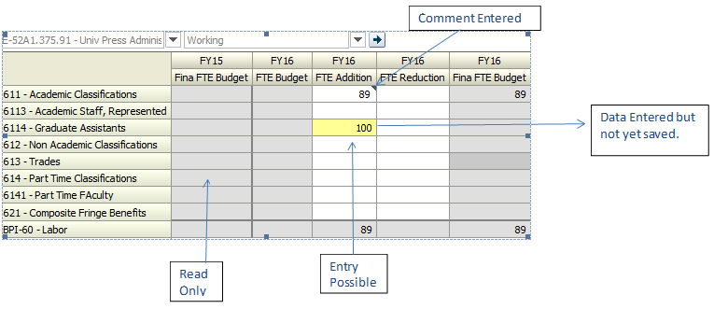
- Note: It is important to make sure prior to data entry, that users ensure no other users have that same data form open. Otherwise, the user who last saves will overwrite the other user’s save.

Navigating in Data Forms
How a user navigates depends on whether they have just clicked in a cell or are editing cell data. For example, when users click in a cell, they can press the right arrow to move to the next cell in the row. When users are editing data in a cell, they must press Tab to move to the next cell.
When clicking in a cell and not entering or editing cell data, to move:
- Forward, backward, up, or down, press the right arrow, left arrow, up arrow, or down arrow key
- To the next cell in the column, press Enter
- To the previous cell in the column, press Shift + Enter

When entering or editing data in cells, to move:
- Forward or backward within the cell data, press the left arrow key or the right arrow key
- To the next cell in the row, press Tab or click in the next cell
- To the previous cell in the row, press Shift + Tab
- To the next cell in the column, press Enter
- To the previous cell in the column, press Shift + Enter

Typing Values in Cells
To enter data in a data form, click a cell and type the value. Cells in the data form that are shaded are display only and data cannot be entered or edited.
As users enter data and tab to the next cell, the background of the cell where data was entered changes to yellow, indicating that the cells were modified. These cells remain yellow until data is saved.

Copying and Pasting Data
During the budgeting process, the expenses for February and March might be the same as that for January. Instead of retyping these values, use the copy and paste function.
Users can copy data from one cell to another cell or copy multiple cells and paste them into the same number of cells. Also users can copy data from an external application such as Excel and paste the data into data forms in Planning.
Data can be selected in the data form using the following methods:
- Select a row or column - To select the entire row or column, click a row or column heading
- Select consecutive cells - To select consecutive cells, click the first cell in the range of cells to select. Then, while pressing the shift key, click the last cell of the range or use the up and down arrow keys to select the cell range.
- Select cells using a cursor - To select cells using a cursor, click a cell and drag the cursor across the range of cells to select

Refreshing and Saving Data
After entering data in a data form the database must be updated with the new budget data. To perform this activity, save the form by clicking the Save icon on the Planning toolbar.
Planning provides a collaborative environment. Many users can view and work with the same plan simultaneously. To ensure the most current plan is shown, click the Refresh icon. Also, use the refresh button to clear changes that don’t need to be saved.
- Note: It is important to make sure prior to data entry, that users ensure that no other users have that same data form open. Otherwise, the user who last saves will overwrite the other user’s save.

Adjusting Values by a Percentage
The Adjust Data feature is available by using the Edit menu or by using the Adjust icon on the Planning toolbar to increase or decrease the value in any cell or a range of cells by a percentage.
- To Adjust Values by a Percentage
- Select the cells to adjust. Adjust data for multiple cells simultaneously, if the writable cells are at the same level. For example, adjust the data for February and March simultaneously, but not for March and Q2.
- Click Adjust .
- Perform an action:
- To increase or decrease values by a specified amount, from Adjust Data, select By Value, select Increase by or Decrease by, and enter the value to spread
- To increase or decrease values by a percentage, from Adjust Data, select By Percentage, select Increase by or Decrease by, and enter the percent value
- 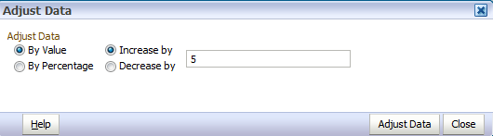
- Note: A numeric value must be entered.
- Click Adjust Data.

Adjusting Values Using Mathematical Operators
Previously entered numbers can be adjusted. Use the following mathematical operators for adjusting data:
- + for addition
- / for division
- % for percentage
- * for multiplication
- +- for subtraction
- To Adjust Values Using Mathematical Operators
- Select the cell to adjust.
- Type the mathematical operator and the number to adjust by and press enter.
The data updates to the adjusted value.
- To save the updated value, click Save on the Planning toolbar.

Data Form Instructions
The creator of the data form may have included some instructions, or helpful hints for preparing current estimates. If instructions are included on a data form, a View link displays in the data form’s instruction column.

Cell Comments
During data entry, users can add comments, or view comments that have been entered by other users.
- Note: All annotations associated with the planning unit are listed and include the owner, the date and time it was created for each.
- Adding Comments to Forms:
- Users have the option to print comments that have been input into web forms. In a cell that accepts data entry, right click into the cell to display the following menu and click Comments.
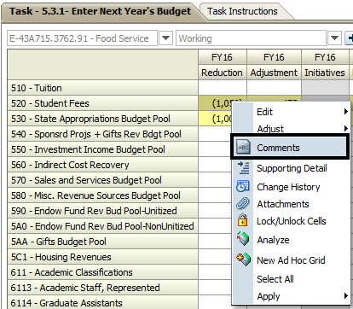
- Click the green plus to add a comment.
- Type comment in the text field.
- Click Add.
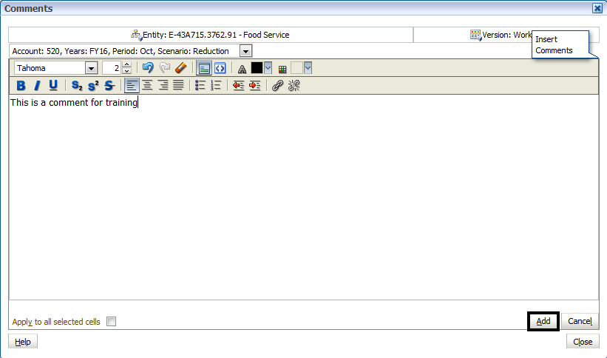
- Click Close.
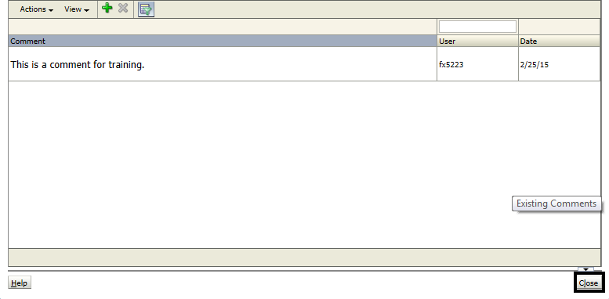
- Note: For FTE adjustments users must enter the Employee ID number.
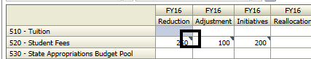

8

Introduction to Financial Reports

Financial Reports
Financial Reports are developed by Administrators and can be accessed in the Hyperion Planning Task Lists. Financial Reports utilize data from Planning and display a report based on specifications.
- Note: WSU decided to use task lists for reporting. For reporting, the Budget Office can use these steps or the Planning task list; however, end users only access the reports via the Planning task list.
- To Open Financial Reports:
- From a task list, click a task that contains a financial report.
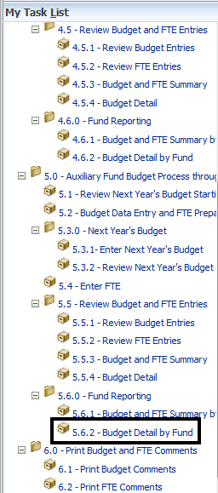
- Click the Member Selector.
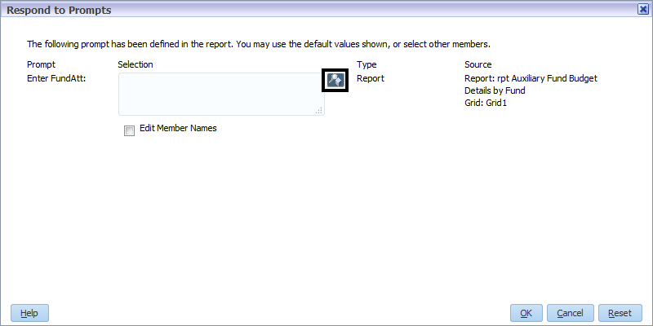
- Select an Entity.
- Click Add.
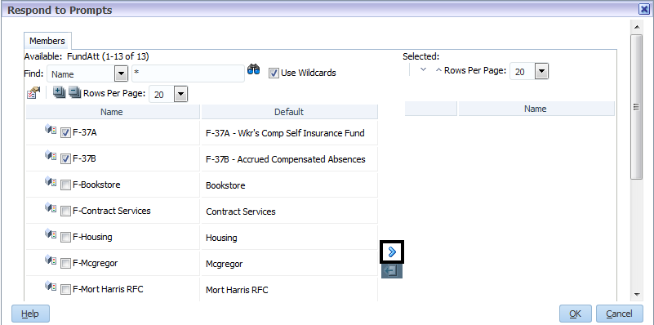
- Click OK.

- Click OK.

- To Change the Point of View:
- On the POV Bar, click the dimension to drill into.
- Expand the dimension hierarchy and select the dimension members to display on the report.
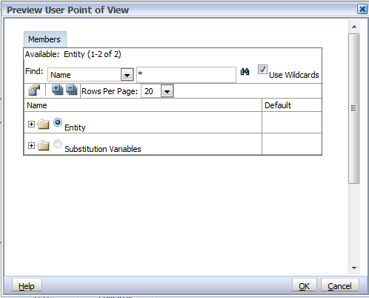
- Note: to quickly locate a dimension member type the name in the text field and click the binoculars.
- Click OK.
The report displays with data for the member selected.

9

Smart View

Smart View Overview
Hyperion Smart View allows users to manipulate Essbase data and Planning data forms in Microsoft Excel. You can use Smart View to enter and analyze data from the Microsoft Excel interface.
With Essbase and Smart View, you can:
- Open individual Essbase cubes
- Conduct ad hoc analyses
- Adjust data and submit back to the Essbase cube
- Conduct advanced ad hoc functionality to streamline processes

When viewing Essbase data in Smart View, users can manipulate, adjust, and alter the data in the grid to meet your specifications. The Essbase Smart view functionality gives users freedom to quickly customize a table to present only data that interests you and make adjustments as necessary.

The Smart View Ribbon
The Smart View Ribbon is the main toolbar used for performing functions in Smart View.
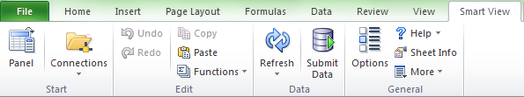
The Start area opens the Smart View Panel where the user can add, edit and delete data source connections. The Connections drop-down menu displays active or recently used connections, and allows the user to reset the current connections to default and access Reporting and Analysis documents.
The Edit area allows users to undo and redo ad hoc functions, copy and paste data points, and create and manage functions using Function builder.
The Data area allows users to refresh data in the current spreadsheet or the entire workbook.
The General area provides access to the Options dialog box, Smart View Help, and Sheet Information. The More drop-down menu allows the user to migrate workbooks from previous releases, insert a connection list, or copy metadata between worksheets.

Connecting to a Data Source
A connection with a data source must be created to begin working with any data source. Users will only have to connect the first time to establish a connection.
- To Establish a Connection:
- In the Smart View ribbon, click Options.
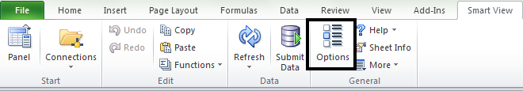
- Select the Advanced tab then enter the database URL in the Shared Connection URL textbox.
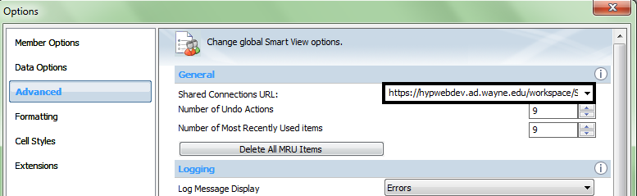
- Click OK.
- If prompted, enter your Username and Password.
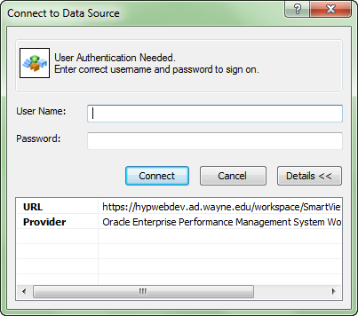
- Click Connect.
- Note: If the user is already working in Excel, it is important that the user opens a new workbook before connecting to the Planning application and opening a data form. If the user does not open a new workbook, the data form will open as a tab on the active workbook and not be connected.

Introduction to Ad Hoc Analysis
Ad Hoc Analysis allows users to select the data values and set restrictions or guidelines on the information that is being analyzed. It is often used as a tool to explore data. An ad hoc analysis is a request to the database server to search its data for specific information or results. Ad hoc queries enable users to view data for specific dimensions from the data source without writing spreadsheet functions.

Creating an Ad Hoc Grid
Ad hoc queries enable users to view data for specific dimensions from the data source without writing spreadsheet functions.
- To Create an Ad Hoc Grid:
- Click the Server drop-down and select Oracle ® Essbase.
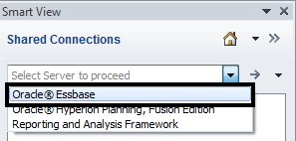
- Expand EssbaseCluster-1.
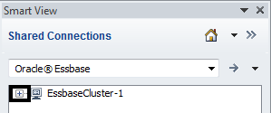

- Expand WSUPLN.
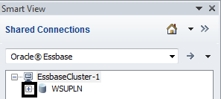
- Click an Essbase cube.
- Click Connect.
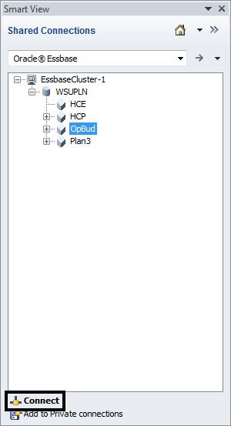
- Enter the Username and Password, if prompted.

- Click Ad Hoc Analysis.
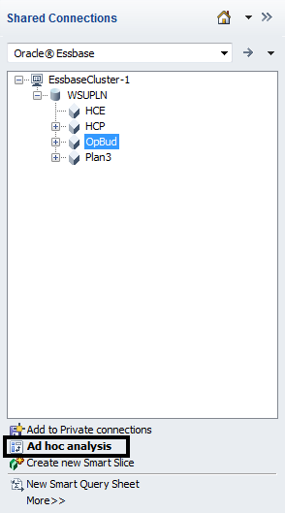

Aliases
Aliases are alternate names for database member names. Database member names are often stock numbers or product codes; their aliases can be more descriptive. For example, an entity member name is the entity number, such as E-04AA. Entity member E-04AA has a descriptive name, or alias, of E-04AA - Provost. Aliases are stored in alias tables as part of a database. Dimensions can be associated with multiple alias tables.
Users can select an alias table for the current worksheet or for a connection. If more than one alias table is created for a dimension, users can select the alias table to display.
To set an alias table for the current worksheet, select Change Alias from the Essbase ribbon.
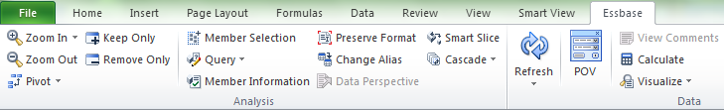

All available tables will present in a separate dialog box. Default is the default alias table and other Alias tables are named in the application. If multiple alias tables are available, they will display in the dialog box.
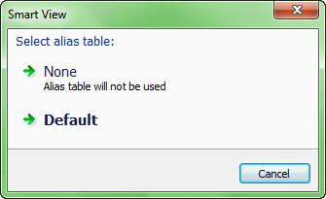
- To Set an Alias Table for a Connection:
- Click an Essbase cube.
- Click Connect.
- Enter the Username and Password, if prompted.

- Click Ad Hoc Analysis.
- Click Change Alias.
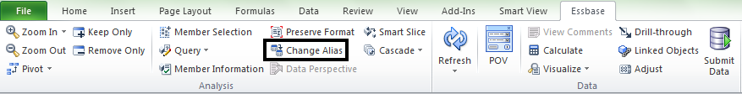
- Select an Alias table.
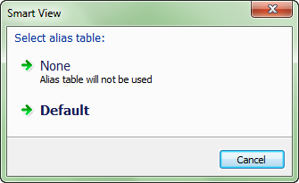

Changing the Point of View (POV)
The Point of View (POV) bar displays members not defined in the grid. By changing the POV, users can dynamically change what data displays and calculates.
- To Change the Point of View (POV):
- On the Essbase Ribbon select the POV icon 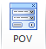 .
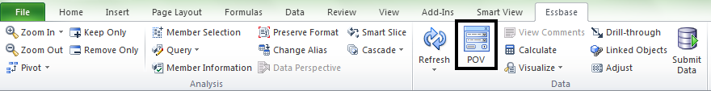
The POV menu will open.
- Use the dimension drop-down and select “…” (ellipses).
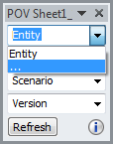
- Select the members to be displayed in the table by checking their checkbox.
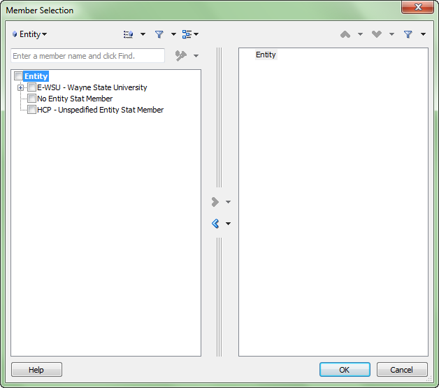
- Click Add to add the selected dimensions to the POV. Click Remove to remove the selected dimensions from the POV.
- Click OK.
- In the POV box, click the Dimension drop-down that members were selected for in the previous steps and click the desired member to set as the POV.
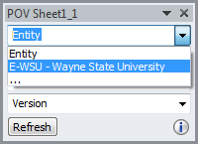
- Note: Only one member of a dimension can be represented in the POV at a time.
- Click Refresh.
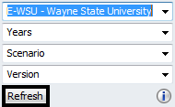
The new values display on the table.

Refreshing the Grid
There are multiple ways to refresh the grid.
- Click the Refresh button in the Essbase Ribbon
- Click Refresh on the POV toolbar
- Double-click on a blank cell in the worksheet

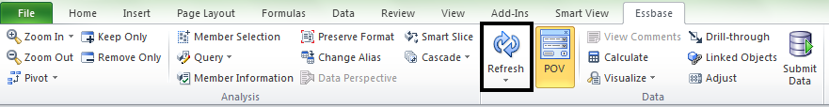

Smart View Zoom
Smart View allows for zooming in on a member in a grid to display data for their children and descendants. By default, using Zoom In zooms in to the children of the selected member. Within the Essbase Smart View options, users can also set the default zoom function to display members on the same level, generation or sibling level as the selected member and members that are defined by the formula of the selected member.

Setting a Default Zoom
Users can specify a default for zooming operations. The default zoom applies to double-click zooming and the zoom in button.
- To Set a Default Zoom:
- Select Options from the Smart View ribbon.
- Select the Member Options tab drop-down.

- Select the Zoom In Level drop-down.
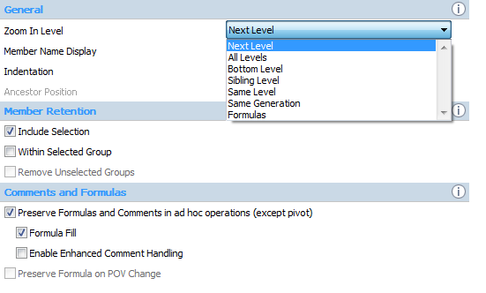
- Set the default zoom level from the drop-down selection of Next Level, All Levels, Bottom Level, Sibling Level, Same Level, Same Generation or Formulas.

Selecting Member to Display when Zooming
Users can set options to specify which members are retained and displayed as zooms occur. To set members to display, select Options from the Smart View Ribbon and select Member Options in the left panel of the dialog box. Under Member retention select:
- Include Selection - Displays both the selected member and the members retrieved as a result of the zoom operation
- Within Selected Group - Zoom to only the selected group of cells, leaving the unselected cells as is
- Remove Unselected Groups - Removes all dimensions and members except the selected member and the members retrieved as a result of the zoom operations

Zooming In
Smart View allows for zooming into a selected cell based on a zoom in selection. To zoom in, select the cell or member for zooming. From the Essbase ribbon, click the drop-down arrow beside the Zoom In member of the ribbon . The drop-down selection box will allow for zoom in to various levels.
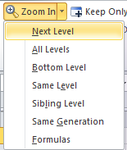
The results of the zoom vary depending on the zoom selection from the drop-down list. In the example below, YearTotal was the selected cell and Zoom In to Next Level was selected from the drop-down. The results of the zoom are below:
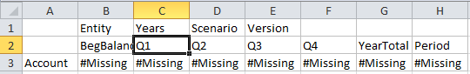
The next level of the YearTotal is shown after the zoom was executed.

Zooming Out
Zooming Out collapses the existing or current view based on the default zoom level. Zoom Out is selected from the Essbase Ribbon .
Based on the example above, if YearTotal is selected and Zoom Out is selected from the Essbase ribbon the following would be the result:
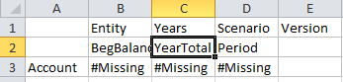

Enable Double-Click Zooming
Double-Click Zooming can be turned on by going to the Options button on the Smart View Ribbon. Click the Advanced Options tab. Under the Mode heading click the Use Double Click for Operations button.

Pivoting
Users can pivot a dimension between rows and columns if there are two or more dimensions in the row or column that contains the dimension the user wants to pivot. Users can also pivot a member; if users do so, the other member in its group is also pivoted.
- To Pivot a Dimension or Member:
- Select a dimension or member.
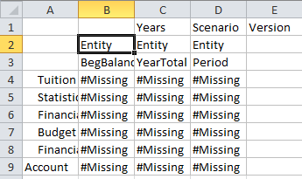
- From the Essbase or Planning ribbon, click Pivot.
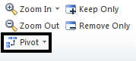
- Row dimensions are pivoted to the topmost column dimension.
- Column dimensions are pivoted to the leftmost row dimension.
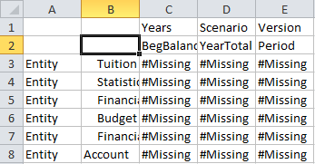
- To Pivot a Dimension or Member to the POV:
- Select a dimension or member.
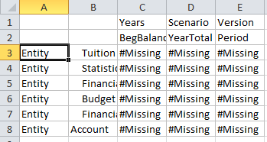
- From the Essbase or Planning ribbon, click the Pivot drop-down.
- Click Pivot To POV.
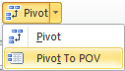
- Grid dimensions are pivoted to the POV.

Keep Only and Remove Only
Users can keep or remove members and their associated data from the grid as follows:
- To keep only the currently selected members, select the member cells to keep. From the Essbase or Planning ribbon, click Keep Only. All other members in the dimension are removed.
- To remove only certain members, select the cells to be removed. From the Essbase or Planning ribbon, click Remove Only.

Keep Only and Remove Only operate on all instances of the selected members in the grid.
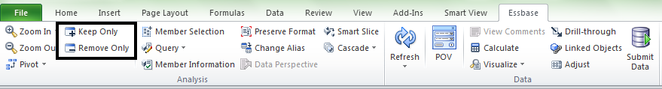

Query Designer
Query Designer is used to create report layouts and select members to match user specifications. Query Designer is much like ad hoc analysis, but includes extra functionality that can be useful. With Query Designer, users can:
- Design queries from default reports
- Extract queries from existing reports
- Share queries with other users
- To Create a Query Using Query Designer:
- Connect to a data source.
- Click More >>.
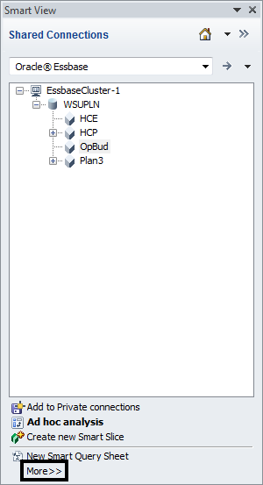

- Click Query Designer.
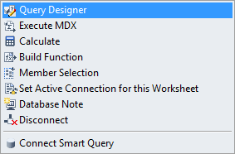
- Drag the dimension and members within the POV window to adjust the grid layout.
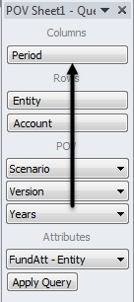
- Click the drop-down arrow for a dimension.
- Click the … to select members.
- Click the checkboxes of members to add.

- Click Add.
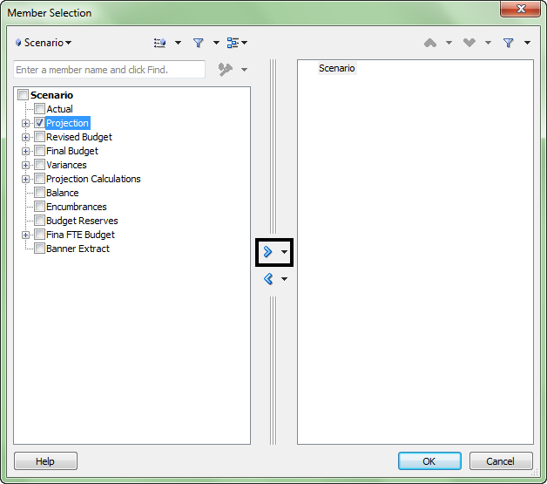
- Click the members to remove.
- Click Remove .
- Click OK.
- After adjustments have been made, click Apply Query.
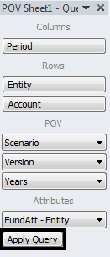

Substitution Variables
Substitution variables are global placeholders that represent variable values. For example, &CurMnth might be a substitution variable representing the current month. Application designers or administrators define and manage substitution variables and their corresponding values; Smart View users can enter a substitution variable into the grid and retrieve its value by refreshing.
For example, say the value for substitution variable &CurMnth is August. When users enter &CurMnth into a grid, Smart View displays August after a refresh. Later, if the value is changed to September, then September is displayed after the refresh when users enter &CurMnth
- To Retrieve the Value for a Substitute Variable:
- Type a substitution variable into a cell in the grid.
- From any ribbon, select Refresh.
The current value defined for substitution variable replaces the substitution variable in the cell and for all cells in the current worksheet that contain &CurMnth.
- Note: Substitution variable names must begin with an ampersand (&).

Formatting Ad Hoc Grids
Users can choose either Excel formatting or Smart View formatting to control grid formatting.
The Preserve Format feature allows users to capture and apply formatting styles, such as font color or number styles, to selected data cells.

Smart View Formatting
Smart View formatting consists of selections made in the Cell Styles and Formatting pages of the Options dialog box.
- To Set Smart View Formatting Options:
- Select Options from the Smart View ribbon. Select Cell Styles in the left panel of the dialog box to set cell styles.
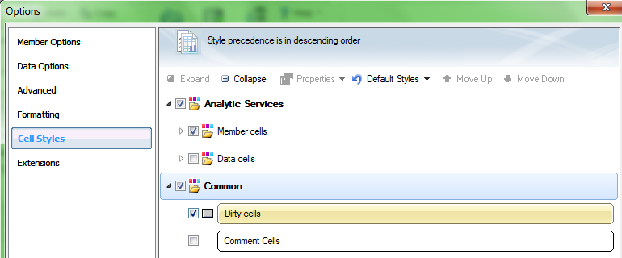
- Set cell styles within the Cell Styles section of the dialog box using the Properties
drop-down select the cell property users would like to format.
- Next check box next to the desired item to format for the member.
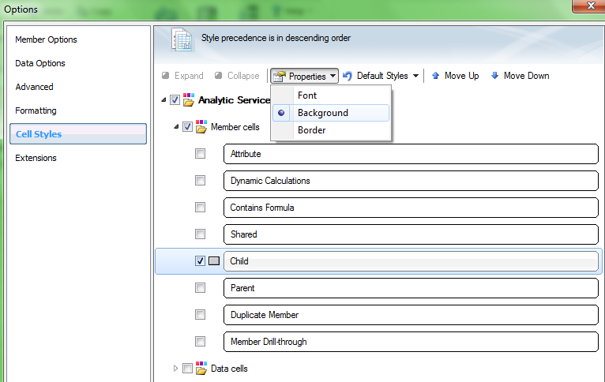
- Select a background color for children cells.
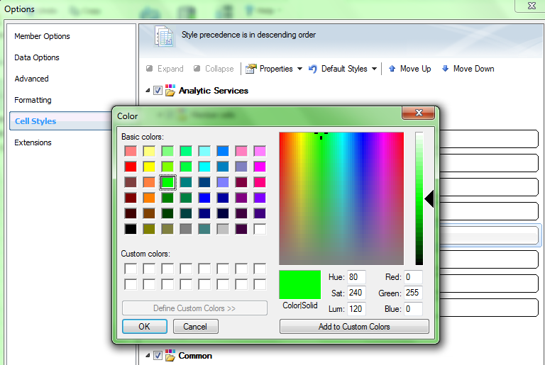
- In the Formatting tab select Use Cell Styles.
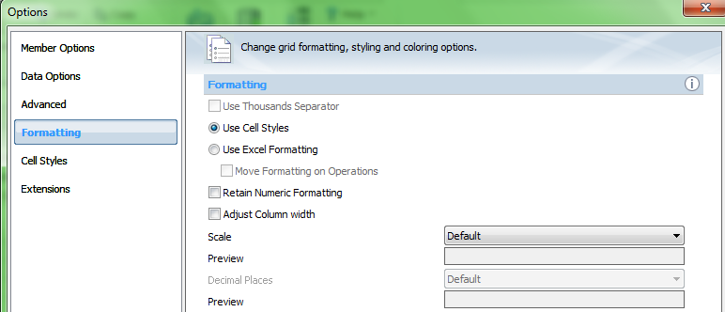
The cell formatting above results in all children members to be shaded green.

Excel Formatting
If using Excel formatting, the user’s formatting selections, including conditional formatting, are applied and retained on the grid when refresh or ad hoc operations are performed.
When using Excel formatting, Smart View does not reformat cells based on the user’s grid operations.
Using Excel formatting is generally preferable for highly formatted reports, and users must use Excel formatting for data sources whose application-specific colors are not supported by the Excel color palate.
- To Use Excel Formatting on Ad Hoc Grids:
- From the Smart View ribbon, select Options.
- Select Formatting from the left pane.
- Select Use Excel Formatting.
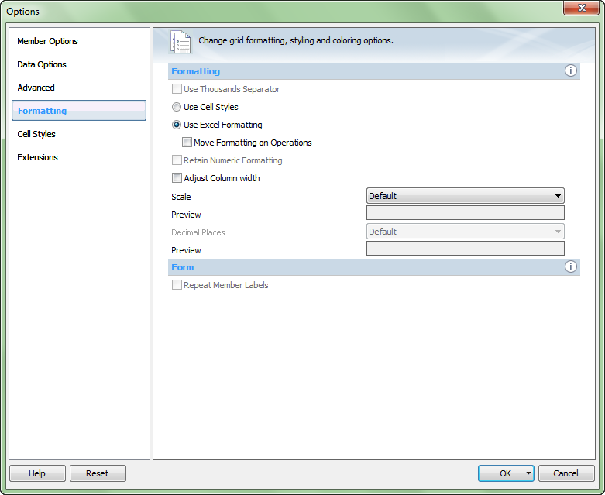
- Note: To copy parent cell formatting to zoomed-in cells, select Move Formatting on Operations.
- Click OK.

Excel Formatting and Merged Cells
To preserve the merged cell formatting during ad hoc operations (except Pivot), users must select both Use Excel Formatting and Preserve Formulas and Comments in Ad hoc Operations options.
To replicate merged cell formatting during ad hoc operations (except Pivot), users must select Use Excel formatting, Preserve Formulas and Comments in ad hoc operations and Format Fill options, as shown below.
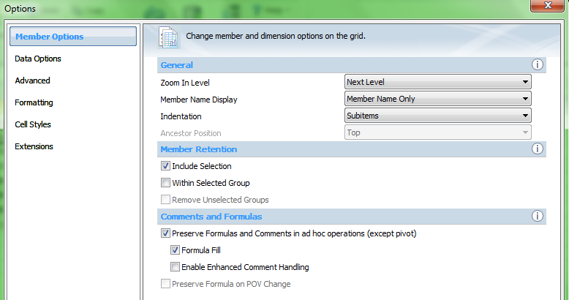

Excel Formulas in Ad Hoc
Excel formulas are preserved when users perform ad hoc operations, except for Pivot. To achieve faster execution of queries, users can disable the preservation of formulas and comments. However, if users select this option, formulas are overwritten when the user performs ad hoc operations.
- To Specify Preservation of Formulas in Ad Hoc Grids:
- Click Options from the Smart View ribbon.
- Select Member Options in the left panel of the dialog box.
- Select Preserve Formulas and Comments in ad hoc operations (except pivot) to preserve formulas
- Clear Preserve Formulas and Comments in ad hoc operations (except pivot) to disable preservation of formulas. This is only recommended if users do not need to preserve formulas and want faster execution of queries.
- Click OK.
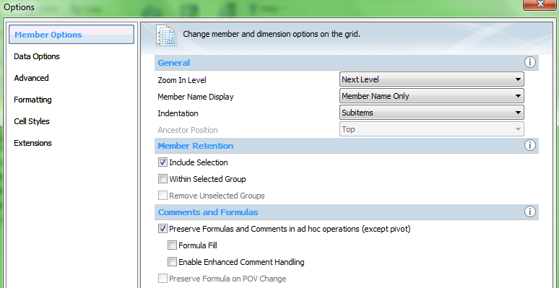

Cascading Reports
Users can create separate reports for any or all members of one dimension in a report based on an ad hoc grid. These reports are cascaded across the worksheets or Excel workbook.
- To Cascade Reports:
- Open an existing ad hoc grid.
- From the Essbase Ribbon, click Cascade.
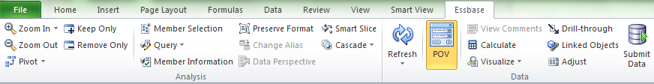
- There are three options from the drop down menu:
  - Same Workbook - Will expand the current workbook
  - New Workbook - Will open a new workbook to display the reports
  - Different Workbooks - Will display each reports in a different workbook
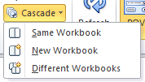
- In the Member Selection box, select the dimension to cascade from the dimension drop-down.
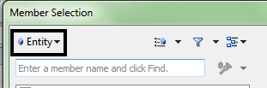

- Select members for each report, click Add.
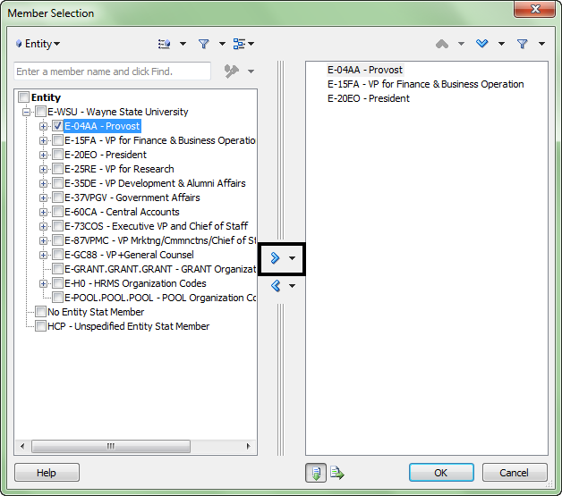
- After the members have been selected, click OK.
- Note: The tabs at the bottom of the workbook will display the member cascade

Typing Values in Cells
To enter data in a data form, click a cell and type the value. Cells in the data form that are shaded are display only and data cannot be entered in or edited.
When entering data and tabbing to the next cell, the background of the cell where data was entered changes to yellow, indicating that the cells were modified. These cells remain yellow until the data is saved.

Copying and Pasting Data
Data can be copied from one cell to another cell or copy a cell and paste it across multiple cells, rows, or columns and paste them in the corresponding number of cells, rows, or columns. Also, data can be copied from an external application such as Excel and paste the data into data forms in Planning.
Select data in the data form using the following methods:
- Select a row or column - To select the entire row or column, click a row or column heading
- Select consecutive cells - To select consecutive cells, click the first cell in the range of cells to select. Then, while pressing the shift key, click the last cell of the range or use the up and down arrow keys to select the cell range.
- Select cells using a cursor - To select cells using a cursor, click a cell and drag the cursor across the range of cells to select

10

Support Discussion

Support Contacts
Issue | Contact
Mozilla Firefox Installation | Technical Administrator
Smart View Installation | Technical Administrator
Hyperion Planning Technical | Susan Qi (Access ID – al8527)
Budgeting Process | Budget Office Representative

