Hyperion Workspace Setup

Step 1: Open Firefox and go to https://addons.mozilla.org/en-US/firefox/addon/remote-xul-manager/
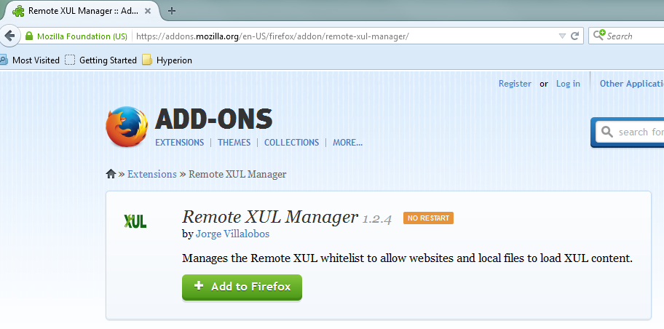
Click “Add to Firefox” to download and install the Remote XUL Manager.
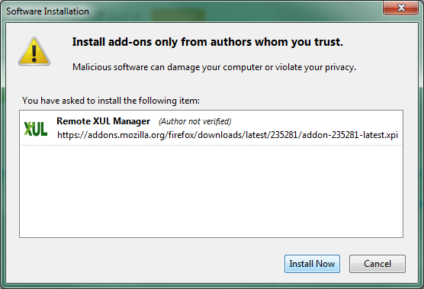
Then install the Remote XUL Manager.
You will need to restart Firefox to complete the installation.
Step 2: Restart Firefox. In the Firefox menu, go to Tools > Web Developer > Remote XUL Manager.
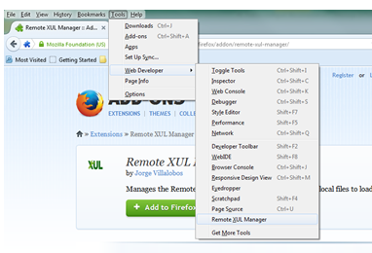
Click Add to enter https://hypwebprod.ad.wayne.edu.
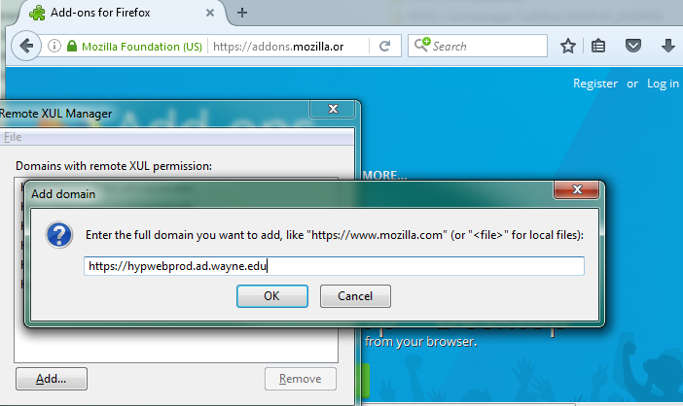
Click OK and then close the Remote XUL Manager by clicking the 'x' in the top-right corner.
Step 3: Restart Firefox to access Hyperion workspace:
https://hypwebprod.ad.wayne.edu/workspace/index.jsp

